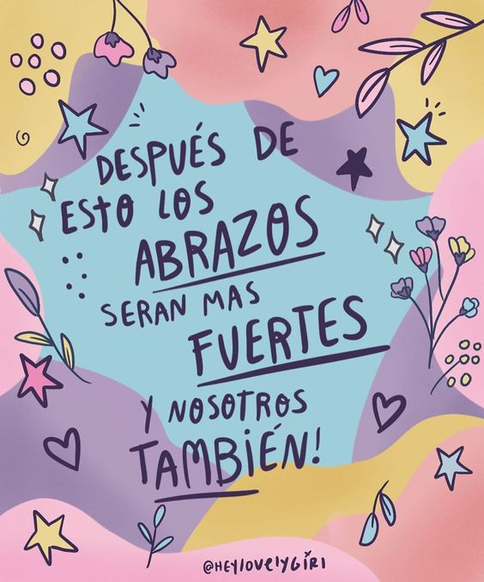
Liceo José Victorino Lastarria, Rancagua
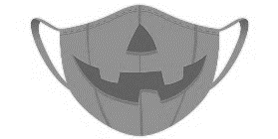
“Formando Técnicos para el mañana”
Unidad Técnico-Pedagógica
Departamento de Inglés

ENGLISH WORKSHEET: Halloween |  |  |  |  | SEMANA:
Nombre Estudiante: |  | ________________________________________ | Curso:________ | Fecha: _________ | 26 al 30 DE OCTUBRE
Objetivo: | Demostrar comprensión lectora de un texto sobre Halloween.
OA: | OF 1 Leer y comprender, en forma autónoma y crítica, distintos tipos de textos escritos, auténticos, relacionados con sus intereses vocacionales.
Instrucciones  Generales : | Desarrollar cada ejercicio y enviar guía a su correspondiente profesor de asignatura.  Profesor Camilo Guarda: camiloguarda1989@gmail.com  Sergio Masciocchi: smasciocchib@gmail.com

Where and When Did Halloween Start?
About 2,000 years ago in the area of the world that is now Ireland, the United Kingdom, and northern France, lived a group of people called the Celts. The Celts' lives revolved around growing their food and considered the end of the year to be the end of the harvest season. So, they celebrated New Year's Eve each year on October 31st with a festival called "Samhain," named after their Lord of the Dead (also known as the Lord of Darkness). Samhain (pronounced 'sow-in') was presided over by Celtic priests called Druids.
Back then, winter was the time of year associated with human death. The Celts believed that on the night that marked the end of summer and the beginning of winter, the boundary between the worlds of the living and the dead blurred allowing ghosts of the dead to return to earth. Celts thought that the presence of the ghosts made it easier for the Druids, their priests, to predict the future. These predictions were an important source of comfort and direction for the Celts during their long, dark, frightening winters.
To celebrate Samhain, the Druids built huge sacred bonfires around which the Celts gathered to burn crops and animals as sacrifices to their ancient gods. During the celebration, the Celts dressed up in costumes consisting of animal heads and skins and tried to tell each other's fortunes.
The Celts eventually were conquered by the Romans, and by about the year 43 AD two Roman festivals were combined with the Celtic Samhain festival. The first Roman festival was Feralia, a day in late October when the Romans traditionally commemorated the passing of the dead. The second was a day to honor Pomona, the Roman goddess of fruit and trees. The symbol of Pomona is the apple and the incorporation of this celebration into Samhain probably explains the tradition of "bobbing" for apples practiced today on Halloween.
By 800 AD, the influence of Christianity spread into Celtic lands. In the seventh century, to replace the Celtic festival of the dead with a related, but church-sanctioned holiday, Pope Boniface IV designated November 1st as All Saints' Day, a time to honor saints and martyrs. The combined and updated celebration was also called All-hallows or All-hallowmas (from Middle English Alholowmesse meaning All Saints' Day) and the night before it, the night of Samhain, began to be called All-hallows Eve and, eventually, Halloween.
Translate the following words.
Blur |  | bonfire
commemorate |  | bobbing
conquer |  | boundary
preside |  | crops
revolve |  | harvest
predict |  | priest

Halloween Facts: True or False?

- The Celts celebrated New Year’s Eve in autumn. _______
- Samhain was the name of the most important Celtic priest. _______
- The Celts thought that ghosts helped the priests to tell the future. _______
- Feralia and Pomona are the names of two Irish festivals. _______
- It was forbidden among the Celts to kill animals. _______
- In the Celtic culture winter symbolised end of life. _______
- “Apple bobbing” is a modern Halloween tradition. _______
- Halloween means “All Saints’ Evening”. _______
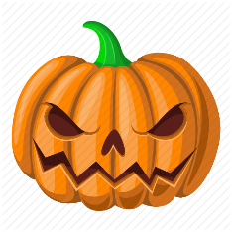
EXIT TICKET
Write three things that people do during Halloween in Chile.

1.__________________________________________________________________________

2. __________________________________________________________________________

3. __________________________________________________________________________

