 Liceo José Victorino Lastarria

Rancagua

“*Formando Técnicos para el mañana”*

Unidad Técnico-Pedagógica

**English worksheet**

**4th Grade Gastronomy**

Name: ______________________________ Date: _____________ Class: 4th _________________

Clase 27 al 31 de Julio

OF 2 Comprender globalmente distintos tipos de textos orales, auténticos, de fuentes y temas variados; procesar, asimilar y reaccionar ante la información recibida de acuerdo a sus propósitos e intereses. Expresión oral y escrita

OF 3 Resolver situaciones comunicativas orales y escritas relacionadas con los ámbitos educacional y laboral; usar el idioma extranjero para establecer contacto, personal o a través de multimedia, con personas de otros países en forma simple y directa.

Objetivo: Demostrar comprensión lectora de un texto alimentos japoneses

Instrucciones: Desarrollar cada ejercicio, luego reenviarlas al correo de su correspondiente profesor de asignatura.

Camilo Guarda: [camiloguarda1989@gmail.com](mailto:camiloguarda1989@gmail.com)

Sergio Masciocchi: [smasciocchib@gmail.com](mailto:smasciocchib@gmail.com)

### Japan’s Healthy Eating Habits

Japanese old saying *hara hachi bu* means "stop eating when you are eight-tenths full." It takes around twenty minutes for the brain to process the information coming from the stomach. If we continue to eat until we feel full, we will overeat. Try it. Stop eating when you feel almost full; you should feel full after less than half an hour.

For the Japanese, a key aspect of food is its savory ( [*umami*](https://wawaza.com/blogs/umami-the-fifth-sensation-of-taste/)) content. Umami is the fifth taste, next to sweet, sour, salty and bitter. Savory foods trigger the secretion of saliva and digestive enzymes, facilitating better breakdown and absorption of nutrients in foods.

Can using chopsticks lead to better health? The short answer is: Probably yes.

Compared to forks and spoons, chopsticks pick up less food. Smaller bites result in more efficient chewing and better digestion. Using chopsticks also slows down the eating process, giving our brain time to figure out we are full and helping us prevent overeating.

### Answer the following questions related to the text.

### *Responde las siguientes preguntas relacionadas con el texto.*

1. What does “hara hachi bu” means?
2. To stop eating before beign full 2) To stop eating only if you are full
3. How long does your brain take to process you are full?
4. 30 minutes 2) 20 Minutes
5. What is “unami”?
6. The fifth flavor 2) Savory foods
7. What does savory food trigger?
8. Smaller bites 2) secretion of saliva and digestive enzymes
9. What’s the difference between chopstick and spoons and forks?
10. The amount of food picked 3) their utility.
11. . Fill the food pyramid with the most representative food of japan. Use the words from the box. Look for pictures in google if you doubt.

Noodles - melon - eggplant –cucumber – rice – garlic – cabbage – radish – mushrooms – seaweed – pear – kobe beef – egg - chicken – takoyaki – jagachoco.

Junk food

Meat, Chicken, Fish

Diary

Fruits

Vegetables

Grains and cereal

1. **Complete the text about Chilean eating habits using some of the words from the previous guide vocabulary.**

VOCABULARY WORDS:

***citrus fruits – dairy – avoid – contain - low-fat – poultry - vitamin C – meat - sweets – heart – milk – c*ereals – fat – salt – sugar – carbohydrates – proteins – vitamins – minerals – fibre – fruit – meat – vegetables.**

*Chilean people usually eat few* ***_____________*** *like eggplants and cucumber**and prefer to eat more* ***_____________*** *like potatoes, rice and pasta.There are three main meals, breakfast where tea or coffee and bread are the most common option, people also consume* ***____________****and ___________ for breakfast. For lunch, ________________ is one of the most popular carbohydrate source, commonly served with fried eggs, which have a lot of _____________ that is not good for our ______________, but is tasty. For dinner we have what we call “once” which commonly consist of bread and coffee. As you can see, Chileans consume a lot of bread and very little ______________ like apples and oranges.*

 Liceo José Victorino Lastarria

Rancagua

“*Formando Técnicos para el mañana”*

Unidad Técnico-Pedagógica

**English worksheet: Reading/writing**

**4th Grade Nursing**

Clase del 27 al 31 de julio.

Name: ______________________________ Date: _____________ Class: 4th ________

OF 1 Leer y comprender, en forma autónoma y crítica, distintos tipos de textos

Objetivo: Demostrar comprensión lectora de un texto sobre fracturas y cortes y crear un texto utilizando vocabulario previo.

Instrucciones: Desarrollar cada ejercicio, luego reenviarlas al correo de su correspondiente profesor de asignatura.

Camilo Guarda: [camiloguarda1989@gmail.com](mailto:camiloguarda1989@gmail.com)

Sergio Masciocchi: [smasciocchib@gmail.com](mailto:smasciocchib@gmail.com)

1. Read the text and solve the exercices. (Lea el texto y resuleva los ejercicios)

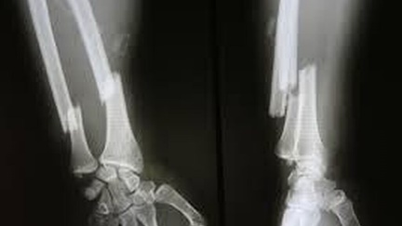First aids for Fractures and Cuts

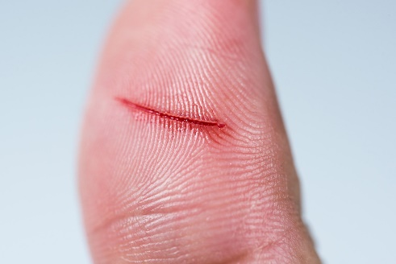Fractures are broken bones, and they can occur as a result of falls or other harsh impacts. When this happens, the affected part should be immobilized, and additional manipulation of the affected area should be avoided. Remember that a fracture could sever a blood vessel or a nerve if it is not immobilized, resulting in a much more severe injury. Immobilize the injured part, and transport the patient to the nearest hospital or medical clinic as soon as possible.

Cut/Scrape: If there is bleeding, press firmly over the site with a clean cloth until it stops, anywhere from three to 15 minutes. Clean with lukewarm running water and gently pat dry. If the skin is broken, apply a thin layer of antibiotic ointment, then cover with a bandage or gauze and adhesive tape. If you can't control the bleeding after several attempts with direct pressure, call your doctor or head to an Emergency Room. Continue utilize antibiotic ointment and apply a new bandage daily (or more often if necessary) until the cut heals. If the wound appears to be forming or draining pus or becomes swollen, tender, or red, see a doctor right away to treat the infection.

1. What are Fractures?

______________________________

______________________________

1. How fractures occur?

______________________________

______________________________

1. Why fractures have to be

Immobilized?

______________________________

______________________________

1. Using words from the previous vocabulary about **professionals**, **wards and departments, aches & pains and injuries**, replace the underline words in the following text and translate. ***(Utilizando palabras de los vocabularios previos, reemplace las palabras subrayadas en el siguiente texto y tradúzcalo.)***

*Last week my mother had a car accident, it was not mortal but she got several injuries; her nose was bleeding, she got a concussion, and some broken bones. She went to the hospital by ambulance. In the surgical ward the surgeon said that we don´t have to worry.*

____________________________________________________________________________________________________________________________________________________________________________________________________________________________________________________________________________________________________________________________________________________________________________________________________________________________________________________________________________________________________________________________________________________________________________________________________________________________________________________________________________________________________________________________________________________________________________________________________________________________________________________________________________________________________________________________________________________________________________________________________________________________________________________________________________________________________________________________________________________________________________________________________________________________________________________________________________________________________________________________________________________________________________________________________________________________________________________________________________________________________________________________________________________________________________________________________________________________________________________________________________________________________________________________________________________________________________________________________________________________________________________________________________________________________________________________________________________________________________________________________________________________________________________________________________________________________________________________________________________________________________________________________________________________________________________________________________________________________________________________________________________________________________________________________________________________________________________________________________________________________________________________________________________________________________________________________________________________________________________________________________________________________________________________________________________________________________________________________________________________________________________________________________________________________________________________________________________________________________________________________________________________________________