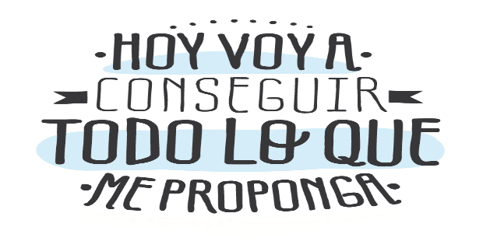
Liceo José Victorino Lastarria
Rancagua
“Formando Técnicos para el mañana”
Unidad Técnico-Pedagógica

English worksheet
4th Grade Gastronomy

Name: ______________________________ Date: _____________ Class: 4th _________________

Clase 27 al 31 de Julio
OF 2 Comprender globalmente distintos tipos de textos orales, auténticos, de fuentes y temas variados; procesar, asimilar y reaccionar ante la información recibida de acuerdo a sus propósitos e intereses. Expresión oral y escrita
OF 3 Resolver situaciones comunicativas orales y escritas relacionadas con los ámbitos educacional y laboral; usar el idioma extranjero para establecer contacto, personal o a través de multimedia, con personas de otros países en forma simple y directa.
Objetivo: Demostrar comprensión lectora de un texto alimentos japoneses
Instrucciones: Desarrollar cada ejercicio, luego reenviarlas al correo de su correspondiente profesor de asignatura.
Camilo Guarda: camiloguarda1989@gmail.com
Sergio Masciocchi: smasciocchib@gmail.com

Japan’s Healthy Eating Habits
Japanese old saying hara hachi bu means "stop eating when you are eight-tenths full." It takes around twenty minutes for the brain to process the information coming from the stomach. If we continue to eat until we feel full, we will overeat. Try it. Stop eating when you feel almost full; you should feel full after less than half an hour.
For the Japanese, a key aspect of food is its savory ( umami) content. Umami is the fifth taste, next to sweet, sour, salty and bitter. Savory foods trigger the secretion of saliva and digestive enzymes, facilitating better breakdown and absorption of nutrients in foods.
Can using chopsticks lead to better health? The short answer is: Probably yes.
Compared to forks and spoons, chopsticks pick up less food. Smaller bites result in more efficient chewing and better digestion. Using chopsticks also slows down the eating process, giving our brain time to figure out we are full and helping us prevent overeating.

Answer the following questions related to the text.

Responde las siguientes preguntas relacionadas con el texto.
- What does “hara hachi bu” means?
___________________________________________________________________
- How long does your brain take to process you are full?
___________________________________________________________________
- What is “unami”?
___________________________________________________________________
- What does savory food trigger?
___________________________________________________________________
- What’s the difference between chopstick and spoons and forks?
___________________________________________________________________

- According with information form internet and your own knowledge and the previous guide. Fill the food pyramid with the most representative food of japan. Add at least one example on each category.
Junk food
Meat, Chicken, Fish
Diary
Fruits
Vegetables
Grains and cereal

- Write a short text describing Chilean eating habits. using at least 10 of the words from the previous guide vocabulary. Follow the example.
VOCABULARY WORDS:
citrus fruits – dairy – avoid – contain - low-fat – poultry - vitamin C – meat - sweets – heart – milk – cereals – fat – salt – sugar – carbohydrates – proteins – vitamins – minerals – fibre – fruit – meat – vegetables.

E.g. Chilean people usually eat few vegetables and prefer to eat more carbohydrates. Potatoes, rice and pasta are the most consumed.There are three main meals, break fast where tea or coffee and bread are the most common option, people also consume milk and cereals for breakfast...

