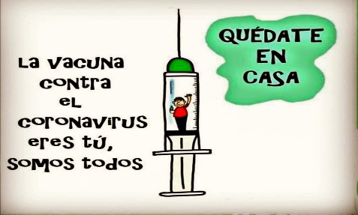
Liceo José Victorino Lastarria
Rancagua
“Formando Técnicos para el mañana”
Unidad Técnico-Pedagógica

English worksheet: Review
4rd Grade Nursing

Semana del 1 al 5 de junio.
Name: ______________________________ Date: _____________ Class: 3rd ________
OA 3: Redactar textos cortos con temáticas conocidas.
Objetivo: Reconocer y reforzar vocabulario visto y crear oraciones relacionadas.
Instrucciones: Desarrollar cada ejercicio, luego reenviarlas al correo de su correspondiente profesor de asignatura.
Camilo Guarda: Camilo guarda1989@gmail.com
Sergio Masciocchi: smasciocchib@gmail.com

I.- Write the correct meaning for the following words related to hospital (Escriba el significado correcto relacionado a Hospital)
1.- Surgical ward = ________________________
2.- Medical ward = ________________________
3.- Orthopaedic ward = ________________________
4.- Gynaecological ward = ________________________
5.- Paediatric ward = ________________________
6.- Dermatological ward = ________________________
7.- E.N.T ward = ________________________
8.- Long-stay ward = ________________________
9.- Intensive Care Unit = ________________________
10.-X-ray Department = ________________________

II. Put the correct number from column A in the meaning in column B. (Colocar el numero correcto de la columna A en el significado de la columna B)

A B

1.- Injuries ______ torcer
2.- a plaster ______ puntos
3.- sling ______ exámenes de sangre
4.- bruise ______ heridas
5.- bleeding ______ hematoma
6.- damage ______ contusión
7.- concussion ______ cortar
8.- stitches ______ cabestrillo
9.- cut ______ daño
10.-blood tests ______ un yeso
11.-swollen ______ hinchado
12.-twist ______ sangrando

III. Where could you find a.....? (¿Dónde se puede encontrar a un…?)
1.- Where could you find a Dermatologist?
In a ________________________ ward
2.- Where could you find a Radiologist?
In an ___________________________ department
3.- Where could you find an Obstetrician?
In a ___________________________ unit
4.- Where could you find a Surgeon?
In an __________________________ Theatre
5.- Where could you find a Pediatrician?
In a _________________________ ward

II.- WRITE IN ENGLISH OR SPANISH THE FOLLOWING WORDS: (Escriba en español o inglés según corresponda)

1.- Resaca = _____________________ 6.- runny nose = __________________
2.- alergia = _____________________ 7.- cough = __________________
3.- doloroso = _____________________ 8.- injection = __________________
4.- receta = _____________________ 9.- chemist = __________________
5.- mareado = _____________________ 10.- flu = __________________

III.- FILL IN THE BLANKS: (Completar los espacios en blanco)
1.- A ____________________ is caused by a weapon

2.- Sarah has a ____________________ in her leg, now it is swollen

3.- Paul’s finger is bleeding a lot, so he has to put a ____________________

4.- I went to the Doctor and he gave a __________________________ for some tablets.

5.- Carol broke her arm and now she is using a ______________ and a _______________

6.- An _________________ is a damage to a part of your body caused by an accident

7.- A ___________________ is a serious condition caused by an infecction.

8.- Hapatitis is a ______________________ disease

9.- Asthma caused ________________________ problems

10.- Sam has got a _______________________ now he is confused

11.- A solution for twisting an ankle is to ___________________

12.- I burnt my hand yesterday, now I have to use a _________________ and put a __________________ on it.

13.- A solution for a bruise is an ________ __________

14.- Peter had a cut on his forehead and now has five ________________________ on it.

15.- _______________ is more serious than a cold.

IV. TRASLATE 6 SENTENCES FRON EXERCICE III. (Traducir 6 oraciones vistas en el ejercicio III)

- ______________________________________________________________

- ______________________________________________________________

- ______________________________________________________________

- ______________________________________________________________

- ______________________________________________________________

- ______________________________________________________________

