Liceo José Victorino Lastarria
Rancagua
“Formando Técnicos para el mañana
Unidad Técnico-Pedagógica

English worksheet: Listening comprehension.
4th grade - Gastronomy
Name: ______________________ Date: ______________ Class: 4th: ______
Semana del 25 al 29 de Mayo.
OA1 : Demostrar comprensión auditiva de un texto adaptado.
Objetivo: Ver video sobre receta y desarrollar ejercicios de comprensión y producción
Instrucciones: Desarrollar los ejercicios y reenviar a su correspondiente profesor de asignatura.
Camilo Guarda: camiloguarda1989@gmail.com
Sergio Masciocchi: smasciocchib@gmail.com

Antes de comenzar, abre el siguiente link en donde encontraras el audio para el primer ejercicio.
https://www.youtube.com/watch?v=jIjzl8I4Bnc

Grilled Chicken Recipe
- Watch the video (How to Make Grilled Chicken) and complete the following recipe using the words from the box.
grill season heat insert place flip brush oil

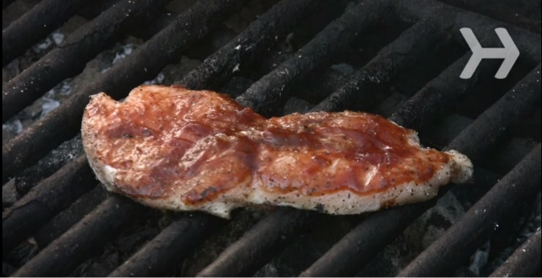
Kitchen utensils
An old towel
A meat thermometer

Ingredients
Canola oil
4 chicken
breast halves
Salt and pepper
1/3 cup of barbecue sauce

Methods
1. _______________ the grill to medium-high and _______________ the grate with an old towel dipped in canola oil.
2. _______________ both sides of the chicken with salt and pepper. _______________ the chicken on the grill.
3. _______________ boneless chicken, without turning, for six to 10 minutes, or 10 to 14 minutes for bone-in. _______________ the chicken and cook the other side.
4. _______________ the thermometer into the thickest part of the meat to test for doneness. Make sure your chicken reaches at least 160 degrees.
5. _______________ on your favorite barbecue sauce about one minute before the chicken is done.

Did You Know?
The body temperature of a chicken ranges from about 104 to 107.5 degrees Fahrenheit.

Antes de comenzar, abre el siguiente link en donde encontraras el audio para el primer ejercicio.
https://www.youtube.com/watch?v=JPdpSAvmnHY

- Listen to the video and answer the following questions.
Escucha el video y responde las siguientes preguntas.

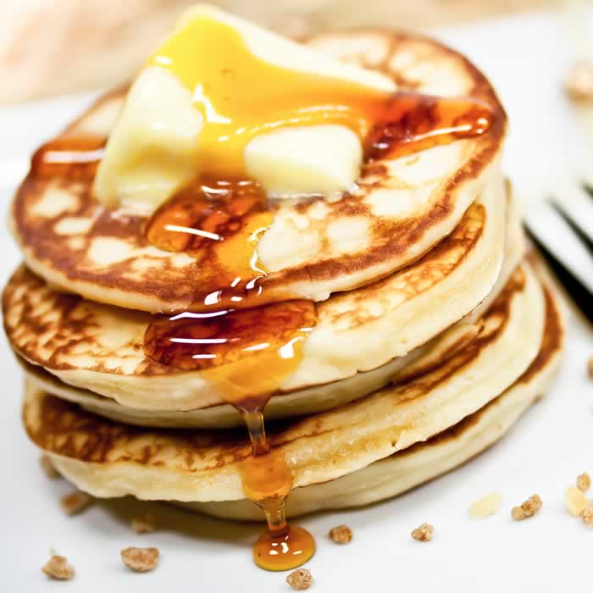
Jamie Oliver makes pancakes
- Who are the two girls?
____________________________________________
- What do they use for measurement?
____________________________________________
- What is the first ingredient they pour in?
____________________________________________
- Which flavors can you add?
____________________________________________
- How do you know that the pancakes are ready?
____________________________________________

- Complete the recipe according to the video. Use the words from the box.
Completa la receta de acuerdo con el video. Usa las palabras del recuadro.
First you _______________________ one cup of self-raising flour and _________________ it in a bowl. Then you _______________________ one cup of milk and a ___________________ of salt. Finally, you _____________________ in one egg and ___________________ the whole batter with a whisker. Finally, you can _______________________ in some pear or other fruit.
Then you _____________________ little piles of the batter into a heated pan with butter. When they are ready on both sides, you can __________________________ a spoonful of yogurt on top and __________________________ some honey on it.
measure – put - mix - pinch – pour (2x) - crack – drizzle - add – grate

