Liceo José Victorino Lastarria
Rancagua
“Formando Técnicos para el mañana”
Unidad Técnico-Pedagógica

English worksheet: Reading / Treatment
4rd Grade Nursing

Name: ______________________________ Date: _____________ Class: 3rd _________________
Clase 7 del 11 al 15 de mayo.
OA 2: Demostrar comprensión lectora de un texto adaptado relacionado a “Treament”
Objetivo de la clase: Reconocer vocabulario de heridas.
Instrucciones: Desarrollar cada ejercicio, luego reenviarlas al correo de su correspondiente profesor de asignatura.
Camilo Guarda: Camilo guarda1989@gmail.com
Sergio Masciocchi: smasciocchib@gmail.com

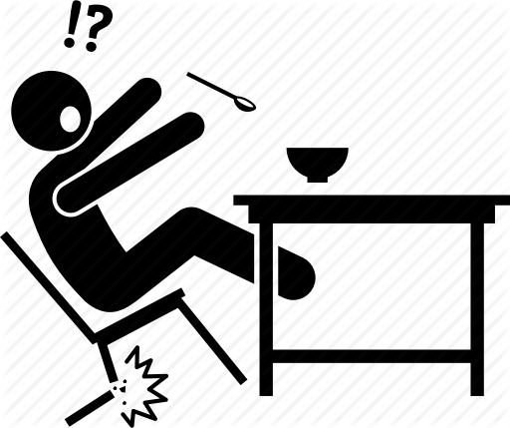
- Read the text, translate it and answer the questions in English. (Lea el texto, tradúzcalo y conteste las preguntas en Inglés)
HOSPITAL TREATMENT

John fell off a chair, hit his head on the floor, and knocked himself unconscious. His wife called an ambulance but John was still unconscious when it arrived. He was rushed to hospital (taken very quickly) where they kept him for two days for blood tests. ___________________________________________________________________

________________________________________________________________________

________________________________________________________________________
________________________________________________________________________

1.- What happened to John?

_____________________________________________
2.- Was John unconscious when the ambulance arrives?

_____________________________________________
3.- How long did he stay in the hospital?

______________________________________________

- Read and translate the text. (Lea y traduce el texto)

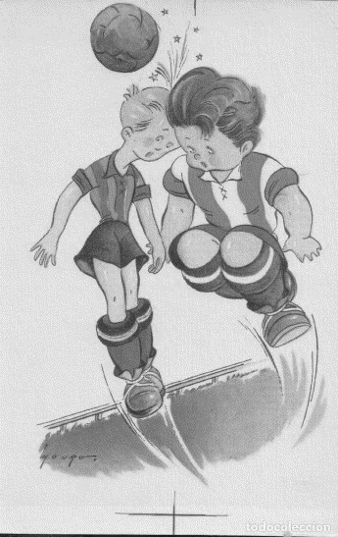
I jumped for the ball and collided with another player (hit each other). We both had cuts on our head, but I had to go to hospital for eight stitches.

______________________________________________________________________

______________________________________________________________________

_______________________________________________________________________

WOUNDS AND INJURIES

Wound and injury are both used to describe damage to the body, but a wound is generally caused by a weapon (e.g. gun or knife) and it is usually intentional.

III.- MATCH: (Escriba el número de la columna A según corresponda en la columna B)

A B
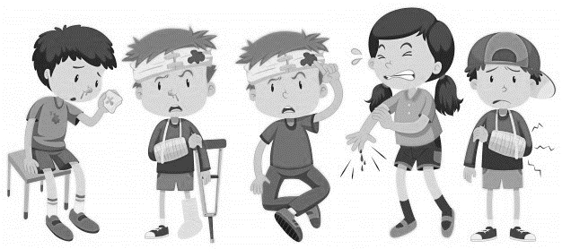
1.- Injury _____ Hematoma
2.- stiches _____ sangrando
3.- damage _____ heridas
4.- sling _____ yeso
5.- plaster _____ cabestrillo
6.- bruise _____ puntos, suturas
7.- bleeding _____ daño
8. Bandage ___8___ bendaje
9. Swollen ______ Hinchado

IV.- SOLVE THE SCRAMBLED WORD PUZZLE. (Resuelva la sopa de letras)

B | A | N | D | A | G | E
R | L | S | A | T | C | S
U | P | W | M | E | X | L
I | T | N | A | L | U | I
S | U | Z | G | I | B | N
E | C | E | E | R | M | G

1.- _________________ 2.- _________________ 3.- ________________

4.- ________________ 5.- ________________
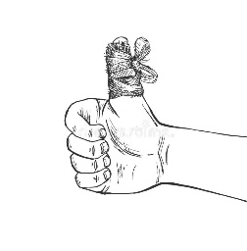
V.- FILL IN THE BLANKS. (Complete los espacios en blanco)
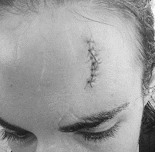
1.- My thumb was bleeding so I put a _____________________ on it.

2.- Peter had a cut on his forehead and now had five __________________ on it.
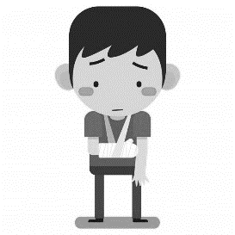
3.- My little sister broke her arm so she had to use ___________________ and _____________
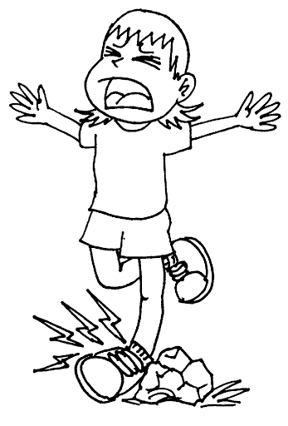
4.- Jenny can’t walk because she ____________________ her ankle.
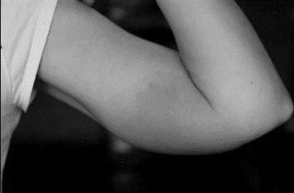
5.- He had a bruise in his arm now it is _______________

