Liceo José Victorino Lastarria
Rancagua
“Formando Técnicos para el mañana”
Unidad Técnico-Pedagógica

Name: ______________________ Date: ______________ Class: 4th: ______
English worksheet: A new diet.
4th grade - Gastronomy

Clase 7, del 11 al 15 de Mayo.
OA2 Leer y deducir la o las ideas principales, integrando información relevante de distintas partes del texto, en textos simples relacionados con los temas del nivel.

Objetivo de la clase: Localizar información general y específica dentro de un texto.

Instrucciones: Desarrollar los ejercicios y reenviar a su correspondiente profesor de asignatura.
Camilo Guarda: camiloguarda1989@gmail.com
Sergio Masciocchi: smasciocchib@gmail.com

FOOD FOR THOUGHT

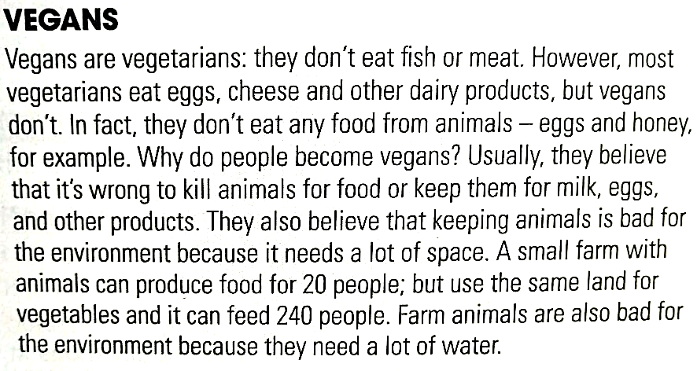

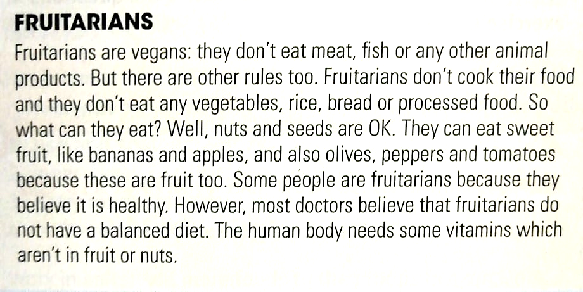

- Read the text and answer the questions.
(Lee el texto y responde las preguntas)

- Why don’t vegans eat eggs or honey?
____________________________________________________________
- What do vegans think about killing animals for food?
____________________________________________________________
- Which need a lot of water: vegetables or farm animals?
____________________________________________________________
- Can a fruitarian eat sandwiches? Give a reason.
____________________________________________________________
- Can a fruitarian eat olives? Give a reason.
____________________________________________________________
d. Why do doctors think a fruitarian diet is not healthy?
____________________________________________________________

- Complete the compound nouns with the words below. When in doubt check the text.
(Completa los sustantivos compuestos con las palabras de abajo. Cuando dudes, revisa el texto)

ANIMAL – BALANCED – DAIRY – FARM – HUMAN - PROCESSED

1 ________________ products 2 ________________ food
3 ________________ animals 4 ________________ diet
5 ________________ products 6 ________________ body

- Complete the sentences with the compound nouns from de previous exercise.
(Complete las oraciones con los sustantivos compuestos del ejercicio anterior)

- Meat, eggs, honey and butter are all _________________.
- A _________________ usually includes rice or pasta, fruit, vegetables and meat or fish.
- The _________________ needs water and food to live.
- Cows, sheep and pigs are all _________________.
- Butter, milk and cheese are all _________________.
- Pizza, burgers and sausages are types of _________________.

