Liceo José Victorino Lastarria
Rancagua
“Formando Técnicos para el mañana”
Unidad Técnico-Pedagógica

Name: ______________________ Date: ______________ Class: 4th: ______
English worksheet: A new diet.
4th grade - Gastronomy

Clase 7, del 11 al 15 de Mayo.
A2 Leer y deducir la o las ideas principales, integrando información relevante de distintas partes del texto, en textos simples relacionados con los temas del nivel.

Objetivo: Localizar información general y específica dentro de un texto.

Instrucciones: Desarrollar los ejercicios y reenviar a su correspondiente profesor de asignatura.
Camilo Guarda: camiloguarda1989@gmail.com
Sergio Masciocchi: smasciocchib@gmail.com

FOOD FOR THOUGHT

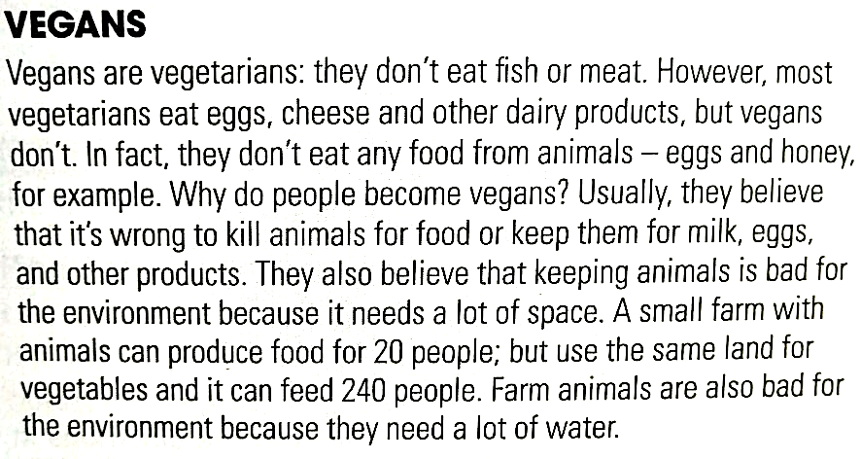

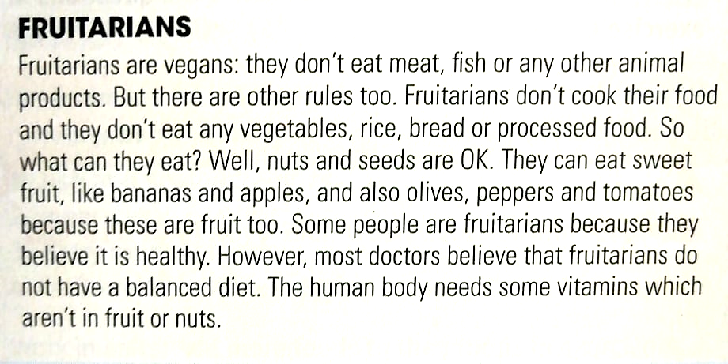

- Read the text and answer the questions.
(Lee el texto y responde las preguntas)

- Why don’t vegans eat eggs or honey?
____________________________________________________________
- What do vegans think about killing animals for food?
____________________________________________________________
- Which need a lot of water: vegetables or farm animals?
____________________________________________________________
- Can a fruitarian eat sandwiches? Give a reason.
____________________________________________________________
- Can a fruitarian eat olives? Give a reason.
____________________________________________________________
d. Why do doctors think a fruitarian diet is not healthy?
____________________________________________________________

- Translate the following compound nouns from the text.
(Traduce los siguientes sustantivos compuestos del textos)

1 Diary products ________________ 2 Processed food ________________
3 Farm animals ________________ 4 Balanced diet ________________
5 Animal products ________________ 6 Human body ________________

- Select the correct compound noun to complete the sentences.
(Selecciona el sustantivo compuesto correcto para completar las oraciones)

- Meat, eggs, honey and butter are all DIARY PRODUCTS / ANIMAL PRODUCTS.
- A BALANCED DIET / PROCESSED FOOD usually includes rice or pasta, fruit, vegetables and meat or fish.
- The ANIMAL PRODUCST / HUMAN BODY needs water and food to live.
- Cows, sheep and pigs are all PROCESSED FOOD / FARM ANIMALS.
- Butter, milk and cheese are all DIARY PRODUCTS / BALANCED DIET
- Pizza, burgers and sausages are types of HUMAN BODY / PROCESSED FOOD

