Liceo José Victorino Lastarria
Rancagua
“Formando Técnicos para el mañana
Unidad Técnico-Pedagógica

English worksheet: A new diet.
4th grade - Gastronomy
Name: ______________________ Date: ______________ Class: 4th: ______
Clase 6, del 4 al 8 de Mayo.
OA2 Leer y deducir la o las ideas principales, integrando información relevante de distintas partes del texto, en textos simples relacionados con los temas del nivel.
Objetivo: Instrucciones: Desarrollar los ejercicios y reenviar a su correspondiente profesor de asignatura.
Camilo Guarda: camiloguarda1989@gmail.com
Sergio Masciocchi: smasciocchib@gmail.com

A luau is a traditional festive meal in Hawaii. People come to the luau to eat, sing and dance. The main part of this outdoor meal is often a kalua pig. Hawaiians cook the pig in an underground oven. They also eat poi, a purple paste. Poi is an important food for Hawaiians. They eat it at almost every meal. For dessert, there is haupia- a coconut pudding.
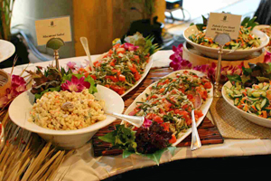

HAWAI

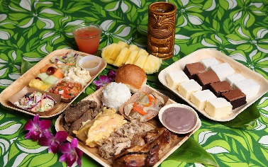
People in Alaska eat many things from the sea-fish, seafood, seal and whale. Alaska is famous for salmon and king crab.
In the summer, Alaskans eat moose and bear. The traditional dessert is Alaska is a special ice cream called akutaq. They make it with animal fat, snow and wild berries- there isn't any sugar in it!

ALASKA
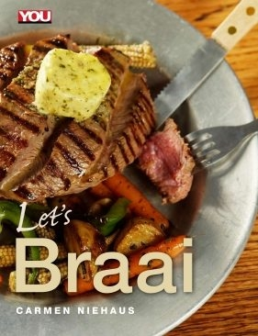
SOUTH AFRICA
On a nice day in South Africa, family and friends meet for the traditional outdoor meal, the braai. At the braai, men cook steak and other types of meat on a fire. There is also a tasty sausage called boerrwors and a thick porridge called mielie pap. South Africans eat mielie pap with their hands.

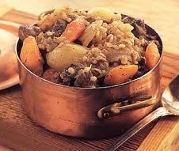
In Ireland, people eat potatoes with most meals. For a traditional breakfast, Irish people eat potatoes, eggs, bacon, sausage and bread.
For lunch, they often have “bangers and mash” (sausages and potatoes). A popular dinner is Irish stew. Traditional Irish stew has got meat, potatoes, carrots, onions and herbs in it.

IRELAND

Answer the following questions:
- Where do people eat:
a traditional meal outdoors?
__________________________________________________
a special dessert?
__________________________________________________
potatoes with most meals?
__________________________________________________
a purple food?
__________________________________________________
- What do Hawaiians have for dessert?
_____________________________________________________________
- What is the most famous food in Alaska?
_____________________________________________________________
- What do men cook at the braai?
_____________________________________________________________

- Produce your own text, to describe a traditional Chilean dish. Use the texts from the reading as an example. (60 words)

__________________________________________________________________________________________________________________________________________________________________________________________________________________________________________________________________________________________________________________________________________________________________________________________________________________
_________________________________________________________________________________________________________________________________________________________________________________________________________

