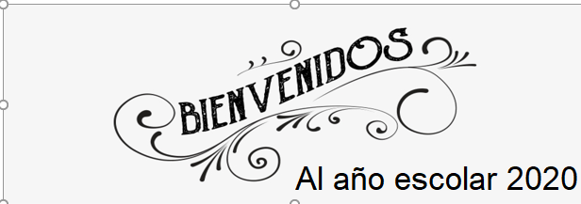

 Liceo José Victorino Lastarria

Rancagua

“*Formando Técnicos para el mañana*

Unidad Técnico-Pedagógica

*English worksheet: Nursing vocabulary*

*4th Grade/ Nursing*

Name: ______________________ Date: ______________ Class: 4th: ______

OA1,

Objetivo: Reforzar y utilizar vocabulario de enfermería.

Instrucciones: Desarrollar los ejercicios y reenviar a su correspondiente profesor de asignatura.

Camilo Guarda: [camiloguarda1989@gmail.com](mailto:camiloguarda1989@gmail.com)

Sergio Masciocchi: [smasciocchib@gmail.com](mailto:smasciocchib@gmail.com)

1. Look for each meaning and Match each Word with the correspondent image. (Busque el significado de cada palabra y escriba el número en la imagen correspondiente)

1. FIRST AID KIT: ___________________

2. BAND AID :__________________

3. OINTMENT :___________________

4. DROPS:____________________

5. SYRUP: ________________________

6. BED REST: ______________________

7. COTTON SWAB:___________________

8. ALCOHOL BOTTLE: _____________________

9. SERUM : ______________________

10. BANDAGE: ____________________

11. PILLS: ________________________

12. SUTURE: ___________________

13. INJECTION: ___________________

14. NEBULIZATOR: __________________

15. CRUTCHES: __________________

16. EFERVESCENT TABLETS: ______________

17. GLASSES: __________________

18. ORTHOPEDIC SHOES: __________________

19. COTTON: ________________________

20. HOT WATER BOTTLE: ________________

21. CAPSULES: ____________________



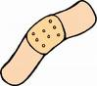MCj03590590000[1]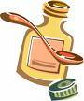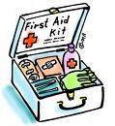MCj04135680000[1]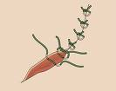DibujoMCj02932760000[1]MCj03254340000[1]MCj03040350000[1]MCj02417270000[1]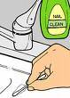22083313

1. Look for the words in the word search puzzle. (Busca la palabra de la lista en la sopa de letras)

