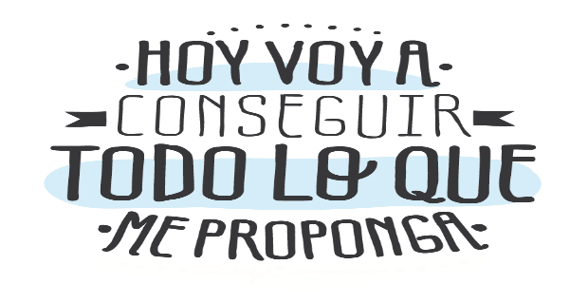
Liceo José Victorino Lastarria
Rancagua
“Formando Técnicos para el mañana”
Unidad Técnico-Pedagógica

English worksheet: Reading comprehension
3rd Grade Gastronomy

Name: ______________________________ Date: _____________ Class: 3rd _________________

Clase del 27 al 31 de Junio
OA3 Utilizar su conocimiento del inglés en la comprensión y producción de textos orales y escritos breves y claros, con el fin de construir una postura personal crítica en contextos relacionados con sus intereses e inquietudes.
Objetivo: Demostrar comprensión Lectora sobre comida típica Mexicana

Instrucciones: Leer el texto y responder las preguntas y ejercicios de acuerdo con este.
Camilo Guarda: Camilo guarda1989@gmail.com
Sergio Masciocchi: smasciocchib@gmail.com
TAMALES IN MEXICO

Tamales, corn dough stuffed with meat, cheese and other delicious additions and wrapped in a banana leaf or a corn husk, make appearances at pretty much every special occasion in Mexico
In many families, groups of women gather together to make hundreds of the little packets -- with each person in charge of one aspect of the cooking process -- to hand out to friends, family and neighbors. On New Year's, it's often served with menudo, a tripe and hominy soup that is famously good for hangovers.
Those who live in cities with large Mexican populations shouldn't have much trouble finding restaurants selling tamales to go for New Year's Eve and Day. But gourmands who want the real deal should head to Mexico City, where steamed tamales are sold from vendors on street corners day and night. They can also be found at established restaurants such as Pujol.
- What does the words in bold in the text mean?
¿Qué significan las palabras en negrita del texto?

DOUGH | MEAT | CHEESE | WRAPPED | BANANA LEAF | CORN  HUSK | TRIPE | HOMINY

- Answer the following questions related to the text.
Responda las siguientes preguntas relacionadas con el texto.

- What’s the filling of tamales?
- Meat and tomato sauce. II) Cheese and Meat. III) Corn and Banana
- Are “Tamales” a meal only eaten during a single special occasion?
- Yes, they are. II) No, they aren’t.
- According to Mexican tradition. Who cooks the tamales?
- The whole family II) The men. III) The women
- Why is it served along with menudo during New Year?

- Because of the cold II) Because of the heavy drinking III) Because it’s a drink
- What is the root of the word “gourmand”?
- Gourmet II) Garoudan II) Gouda
- Where can you find Tamales?
- In restaurants and in the streets II) In restaurants III) In the streets

- Complete the following question with your own ideas. Follow the pattern in the boxes. (Completa las siguientes preguntas con tus propias palabras. Sigue el ejemplo de los recuadros:

- Which Chilean dish do you think, is the most similar to Tamales? Why?
I think that ______________ are the most similar. Because they are ____________ in corn husk too but we don’t use the __________ leaves. The filling is not the same. “Humitas” are filled with _______________.

- Guatitas, is a Chilean dish that uses “tripe”. Describe it by choosing the correct word.
Guatitas, are tripe cooked slowly to make them TENDER/STIFFER. It has many different preparations such as “primavera” which consist of tripe with OTHER MEAT/ VEGETABLES, “chupe de guatitas” that is served in a CLAY BOWL/ METAL BOWL and “carbonada de guatitas” which is similar to the Mexican MENUDO / TAMALES

- In your opinion. How are Mexican and Chilean “cuisine” related?

Liceo José Victorino Lastarria
Rancagua
“Formando Técnicos para el mañana”
Unidad Técnico-Pedagógica

English worksheet: Reading IMMUNE SYSTEM
3rd Grade Nursing

Name: ______________________________ Date: _____________ Class: 3rd _________________

Clase del 27 al 31 de julio
OA3 Utilizar su conocimiento del inglés en la comprensión y producción de textos orales y escritos breves y claros.
Objetivo: Demostrar comprensión lectora de un texto adaptado y completar oraciones con vocabulario previo
Instrucciones: Leer texto sobre sistema inmune. Completar textos cortos.
Camilo Guarda: camiloguarda1989@gmail.com
Sergio Masciocchi: smasciocchib@gmail.com

- Read and fill in the missing words. (Leer y completar con las palabras de cuadro)
Before Reading: What do you know about our immune system?
__________________________________________________________________________________________________________.
Our Immune system
Protects, straight , efficient, remembers, fall ill, defense, prevent, organisms, immune, divided

Our body has a powerful army that 1. …………………..it from various types of threats. This personal army is called the 2. ………………………….system. Every day we encounter a huge number of bacteria, viruses and other disease-causing 3. ……………………... However, we don’t 4. ……………………..every other day. Which is due to our immune system. The immune system can be broadly 5. ………………………..into two parts – innate and adaptive immunity. Innate immunity is the body’s first natural 6. ………………….to any intruder. Its main goal is to 7. …………………………any intruder from entering the body.
There is also the adaptive immunity. This system is more 8. ……………………….., as it can differentiate between different types of pathogens.
The job of the immune system is to fight these pathogens and get them out of the body. What’s so incredible about the immune system is that it 9. …………………………how to fight the infection, so if the pathogen comes back for round two, the body can beat it off 10. ………………………….away!

II. Circle the correct part of the body in each text. (Encierre en un círculo la palabra que corresponda en cada texto corto y complete las partes del cuerpo que faltan en cada cuadro)
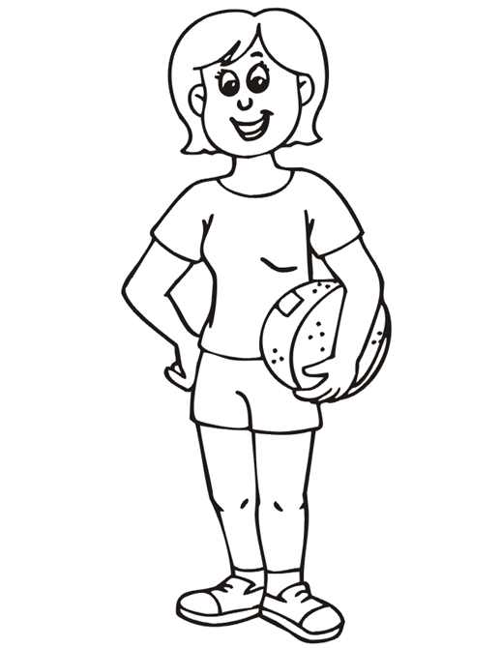
FEET
KNEE
LEG
HAIR
MOUTH
EAR

NECK

ANKLE
HAND

I need my legs/ knees to stand or walk.
I use my teeth/ nails to bite and chew.
I wear a watch on my wrist/ neck .
I need my ears/eyes to hear sounds.
In my face/ foot I have my eyes, ears, nose and mouth.
I use my tongue/ leg for eating, tasting and speaking.
My neck/ arm joins my head to the rest of my body.
I need my eyes / nose to see.
I use my bottom / finger to sit on.
My feet/ hands have five toes each. I use them to walk.

My five
Fingers/ toes are situated at the end of my hand.
I open my
Mouth/ teeth wide when a doctor examines my throat.
My back / face is on the opposite side to my chest and stomach.
My hair/eyebrows grow above my eyes.
My toes /ears are separate parts of my foot.

