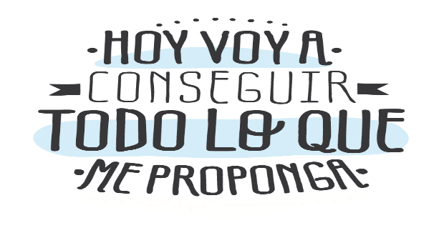
Liceo José Victorino Lastarria
Rancagua
“Formando Técnicos para el mañana”
Unidad Técnico-Pedagógica

English worksheet: IMMUNE SYSTEM
3rd Grade Nursing

Name: ______________________________ Date: _____________ Class: 3rd _________________

Clase del 27 al 31 de julio
OA3 Utilizar su conocimiento del inglés en la comprensión y producción de textos orales y escritos breves y claros.

Objetivo: Demostrar comprensión lectora de un texto adaptado y completar oraciones con vocabulario previo

Instrucciones: Leer texto sobre sistema inmune. Completar textos cortos.
Camilo Guarda: camiloguarda1989@gmail.com
Sergio Masciocchi: smasciocchib@gmail.com

- Read and fill in the missing words. (Leer y completar con las palabras del cuadro)
Before Reading: What do you know about our immune system?
__________________________________________________________________________________________________________.
Our Immune system
Protects, straight , efficient, remembers, fall ill, defense, prevent, organisms, immune, divided

Our body has a powerful army that 1. …………………..it from various types of threats. This personal army is called the 2. ………………………….system. Every day we encounter a huge number of bacteria, viruses and other disease-causing 3. ……………………... However, we don’t 4. ……………………..every other day. Which is due to our immune system. The immune system can be broadly 5. ………………………..into two parts – innate and adaptive immunity. Innate immunity is the body’s first natural 6. ………………….to any intruder. Its main goal is to 7. …………………………any intruder from entering the body.
There is also the adaptive immunity. This system is more 8. ……………………….., as it can differentiate between different types of pathogens.
The job of the immune system is to fight these pathogens and get them out of the body.

What’s so incredible about the immune system is that it 9. …………………………how to fight the infection, so if the pathogen comes back for round two, the body can beat it off 10. ………………………….away!

II. Complete each short text with the correct part of the body and put the correct word in each space in the drawing. (Completar los textos y los cuadros del dibujo con la parte del cuerpo que corresponda.)
My _ _ _ _ _ grow above my eyes.
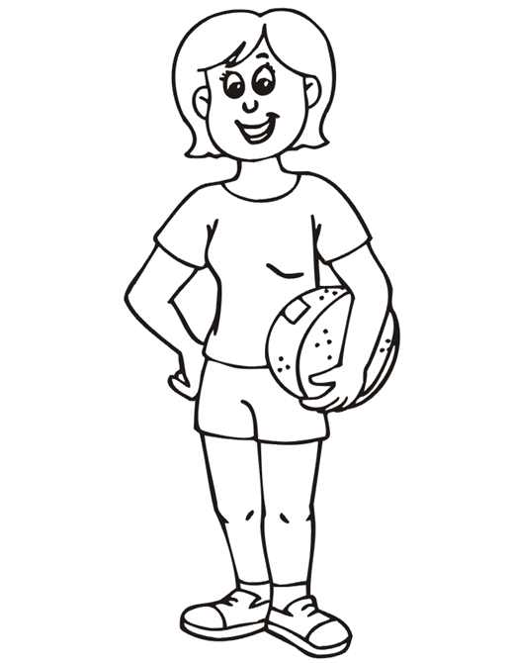
My _ BACK_ is on the opposite side to my chest and stomach.

I open my
_ _ _ _ _ wide when a doctor examines my throat.

My _ _ _ _ have five toes each. I use them to walk.

My
_ _ _ _ _ are separate parts of my foot.

I need my _ _ _ _ _ to see.
BACK

My _ _ _ _ _ are fixed to my shoulders and have hands at the end.
I use my _ _ _ _ _ to sit on.

I need my _ _ _ _ _ to stand or walk.
I use my _ _ _ _ _ for eating, tasting and speaking.
In my _ _ _ _ _ I have my eyes, ears, nose and mouth.

I need my _ _ _ _ _ to breathe and smell.
My five
_ _ _ _ _ are situated at the end of my hand.
I use my _ _ _ _ _ to bite and chew.
I use my _ _ _ _ _ to touch, hold and catch things.
My _ _ _ _ _ can be short, long, curly, straight, dark or fair.

I wear a watch on my _ _ _ _ _ .

My _ _ _ _ _ joins my head to the rest of my body.
I bend my _ _ _ _ _ to say a prayer.
I need my _ _ _ _ _ to hear sounds.

