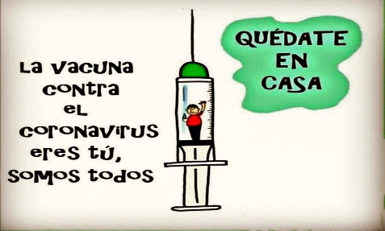
Liceo José Victorino Lastarria
Rancagua
“Formando Técnicos para el mañana”
Unidad Técnico-Pedagógica

ENGLISH WORKSHEET
3rd Grade Gastronomy

Clase 13 del 28 de Junio al 3 de Julio
OA2, OA 3: Leer textos adaptados reconociendo información general y/o especifica. Redactar textos cortos con temáticas conocidas.
Objetivo: Demostrar comprensión Lectora de una reseña de un restaurant y reconocer tiempo presente perfecto.
Instrucciones: Desarrollar cada ejercicio, luego reenviarlas al correo de su correspondiente profesor de asignatura.
Camilo Guarda: Camilo guarda1989@gmail.com
Sergio Masciocchi: smasciocchib@gmail.com
Name: ______________________________ Date: _____________ Class: 3rd _________________

Read the following review of a restaurant and complete the following exercises.
Lee la siguiente reseña de un restaurant y completa los siguientes ejercicios.

Market cuisine on Rancagua’s historical downtown.
In the heart of Rancagua, just a block away from the historical “Plaza de los Heroes”, a small but cozy building, is home to “El Abasto”, a restaurant that has worked since the beginning exclusively with ingredients from the Libertador’s region. In a brave attempt to recover the patrimony of its hometown and its surroundings, the people in charge of the restaurant has found a nice balance between quality and innovation. One of the stars on their dishes is the lamb, which is present on every day’s menu. The lamb is brought from the coastal dray lands of the region and is often accompanied by quinoa, vegetables or other local recipes. Every dish you order will be served along with a cup of Chacoli, Wine or Chicha, if you are not to drink alcohol you can have some natural juice, like it’s refreshing “cucumber and mint juice.”
Another nice aspect from the restaurants is that all tables are shared. So you can meet new people every time you visit it.
Space: 3/5 Food: 5/5 Drinks: 4/5 Price per dish: 5/5

- ¿What’s the name of the restaurant? A) Downtown B) Libertador C) El Abasto
- ¿Where is it located? A) Plaza de los Heroes B) In the heart of Rancagua C) Peru
- ¿What does “cozy” mean? A) Comodo B) Cosa C) Flojo
- ¿What is the star of their dishes? A) Chicken B) Venison C) Lamb
- ¿Do they only serve alcoholic drinks? A) Yes B) N

Let’s check out the “present perfect tense”.
*To use the Present Perfect Tense, we must use the verbs in their “participle” form
Infinitive Past P. Participle Infinitive Past P. Participle
TEACH TAUGHT TAUGHT HIDE HID HIDDEN
*We must also use the Have/ Has verb depending on the subject of the sentence.
I YOU WE THEY = HAVE HE SHE IT = HAS
Eg. I HAVE SENT you a letter – She HAS FINISHED her work.
1. Put the verbs in brackets in the correct present perfect form. (HAVE/HAS + PARTICIPLE FORM) In the case of a negative sentence (HAVE NOT/HAS NOT)
1. Candy HAS KNITTED (knit) a blue sweater for her son.
2. ……………………………… (Alice/ send) you a birthday card?
3. My parents …………………………… (not/ go) to the cinema for two months.
4. The teacher …………………………… (not/ give) us much homework today.
5. ………………………………………… (you/ever/go) to the USA?
6. Mum ………………………… (cook) a delicious diner to celebrate dad’s promotion.
7. Paul …………………………… (not/ choose) the engagement ring yet.
8. You …………………………… (lose) the keys again! I can’t believe it!
9. Sorry, Pete, I …………………………… (forget) to bring your CD back.
10. My laptop ……………………… again this morning (break). The technician …………………
(fix) it three times this month.
11. Cathy ………………………… (not/ wear) the T-shirt I gave her yet.

2. Write the missing forms (infinitive, past, past participle) of these verbs:
FORGET | FORGOT |  | SEE | SAW
WAKE |  |  |  | SHOWED
 |  | FORGIVEN |  | SHAKE
TEACH | TAUGHT |  | HIDE |  | HIDDEN

Liceo José Victorino Lastarria
Rancagua
“Formando Técnicos para el mañana”
Unidad Técnico-Pedagógica

English worksheet: Reading covid-19
3rd Grade Nursing

Name: ______________________________ Date: _____________ Class: 3rd _________________

Clase del 29 de junio al 3 de julio
OA2, OA 3: Leer textos adaptados reconociendo información general y/o especifica. Redactar textos cortos con temáticas conocidas.
Instrucciones: Demostrar comprensión lectora de un texto sobre coronavirus.
Camilo Guarda: Camilo guarda1989@gmail.com
Sergio Masciocchi: smasciocchib@gmail.com

Global Pandemic Vocabulary (TRADUCUIR EL VOCABULARIO SOBRE PANDEMIA)
- State of Emergency / lockdown: ESTADO DE MERGENCIA / CIERRE DE EMERGENCIA
- School closure / school is closed: ____COLEGIOS CERRADOS___________________
- stay at home : _______________________
- quarantine (in a hospital) : __________________________
- self-isolation, quarantine (in your house) : ___________________________
- Covid-19 : _____________
- Social distancing : _______DISTACIA SOCIAL_________
- pandemic : ___________________
- Flatten the curve to keep as many people from getting sick: _____________________________
- Essential workers : ____TRABAJADORES ESENCIALES__________
- Medical staff wearing PPE (Personal Protective Equipment): ___________________________________
- Online school : ____ESCUELA EN LINEA________________

Match the vocabulary to the picture. (INDIQUE EL NUMERO CON LA IMAGEN)
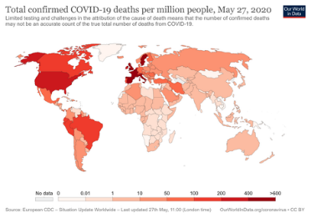
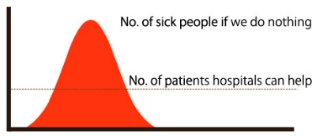
9

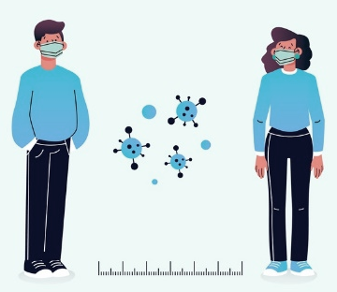
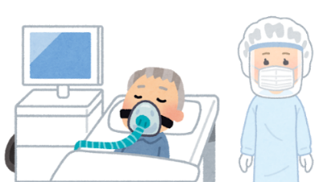
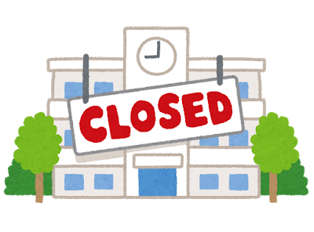
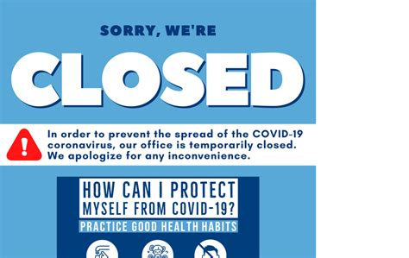
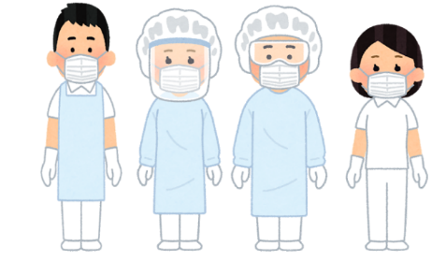
2

8

10

- Read the text and develop the exercises. (Lea el texto y desarrolle los ejercicios)
2020 News: The Coronavirus Pandemic
All around the world, people are getting sick with a new disease called covid-19. Covid-19 is a kind of new coronavirus that started the pandemic this year. From around March, news around the world started talking about “flattening the curve” and “social distancing.” People were told to stay home, but not everyone could. Essential workers like medical staff and supermarket workers still went to work.
On Instagram and other social media, people started to encourage one another to stay at home. There are several other words for “staying at home.” “Self-isolation” and sometimes “quarantine” also means “staying at home.” Quarantine is usually a word we use for hospital quarantines. Quarantine means the patient is alone in their hospital room, and the medical staff wears special equipment (Personal Protection Equipment) to keep from getting sick.
Not long after the coronavirus began to spread around the world, the World Health Organization (WHO) declared it to be a pandemic. Not long after, a state of emergency was declared in many countries, and some places went into lockdown. Many shops were closed, and many people started to work from home. School closures became common in many countries. As a result, many teachers began online classes.
Many students around the world learned how to use Google Classroom (or other online classroom platforms) to continue school. Online schooling during quarantine can be quite difficult. Students are sometimes home alone, while other students do not have a computer they can use. Other students stay up very late. Just the same, online school can help students learn while they are in self-isolation.
Comprehension Questions
True or False (Indique verdadero o falso)
1. Quarantine can mean the same thing as “stay at home.” _____
2. Teachers started using online schooling like Google Classroom. _____
3. Many shops opened during the state of emergency. ____
4. Essential Employees can stay at home during a pandemic. _____
5. All students have a computer, so online schooling is easy. _____
1. What does Covid-19 mean?
A. Pandemic
B. The new coronavirus that began during 2019
C. Quarantine
D. Personal Protection Equipment

2. When was a “state of emergency” declared?
A. Before WHO declared Covid-19 to be a pandemic.
B. After WHO declared Covid-19 to be a pandemic.
C. In March.
D. During quarantine.
3. How do doctors and nurses stay healthy?
A. They stay at home.
Enviar respuestas al correo de tu profesor:
Camilo Guarda: Camilo guarda1989@gmail.com
Sergio Masciocchi: smasciocchib@gmail.com

B. They wear PPE.
C. Shops closed during the state of emergency.
D. Many schools started using Google Classroom

