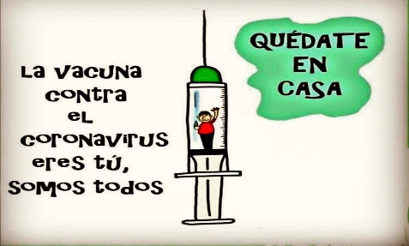
Liceo José Victorino Lastarria
Rancagua
“Formando Técnicos para el mañana”
Unidad Técnico-Pedagógica

ENGLISH WORKSHEET: 3RD GRADE GASTRONOMY

Name: ______________________________ Date: _____________ Class: 3rd _________________

Clase 13 del 28 de Junio al 3 de Julio
OA2, OA 3: Leer textos adaptados reconociendo información general y/o especifica. Redactar textos cortos con temáticas conocidas.
Objetivo: Demostrar comprensión Lectora de una reseña de un restaurant y reconocer tiempo presente perfecto.
Instrucciones: Desarrollar cada ejercicio, luego reenviarlas al correo de su correspondiente profesor de asignatura.
Camilo Guarda: Camilo guarda1989@gmail.com
Sergio Masciocchi: smasciocchib@gmail.com

Read the following review of a restaurant and complete the following exercises.
Lee la siguiente reseña de un restaurant y completa los siguientes ejercicios.

Market cuisine on Rancagua’s historical downtown.
In the heart of Rancagua, just a block away from the historical “Plaza de los Heroes”, a small but cozy building, is home to “El Abasto”, a restaurant that has worked since the beginning exclusively with ingredients from the Libertador’s region. In a brave attempt to recover the patrimony of its hometown and its surroundings, the people in charge of the restaurant has found a nice balance between quality and innovation. One of the stars on their dishes is the lamb, which is present on every day’s menu. The lamb is brought from the coastal dray lands of the region and is often accompanied by quinoa, vegetables or other local recipes. Every dish you order will be served along with a cup of Chacoli, Wine or Chicha, if you are not to drink alcohol you can have some natural juice, like it’s refreshing “cucumber and mint juice.”
Another nice aspect from the restaurants is that all tables are shared. So you can meet new people every time you visit it.
Space: 3/5 Food: 5/5 Drinks: 4/5 Price per dish: 5/5

- ¿What’s the name of the restaurant? _________________________________________________
- ¿Where is it located? _________________________________________________
- ¿What does “cozy” mean? _________________________________________________

4.- ¿What is the star of their dishes? _________________________________________________
5.- ¿Do they only serve alcoholic drinks? _________________________________________________
Let’s check out the “present perfect tense”.
*To use the Present Perfect Tense, we must use the verbs in their “participle” form
Infinitive Past P. Participle Infinitive Past P. Participle
TEACH TAUGHT TAUGHT HIDE HID HIDDEN
*We must also use the Have/ Has verb depending on the subject of the sentence.
I YOU WE THEY = HAVE HE SHE IT = HAS
EX:. I HAVE SENT you a letter – She HAS FINISHED her work.
1. Put the verbs in brackets in the correct present perfect form. (HAVE/HAS + PARTICIPLE FORM) In the case of a negative sentence (HAVE NOT/HAS NOT)
1. Candy HAS KNITTED (knit) a blue sweater for her son.
2. ……………………………… (Alice/ send) you a birthday card?
3. My parents …………………………… (not/ go) to the cinema for two months.
4. The teacher …………………………… (not/ give) us much homework today.
5. ………………………………………… (you/ever/go) to the USA?
6. Mum ………………………… (cook) a delicious diner to celebrate dad’s promotion.
7. Paul …………………………… (not/ choose) the engagement ring yet.
8. You …………………………… (lose) the keys again! I can’t believe it!
9. Sorry, Pete, I …………………………… (forget) to bring your CD back.
10. My laptop ……………………… again this morning (break). The technician …………………
(fix) it three times this month.
11. Cathy ………………………… (not/ wear) the T-shirt I gave her yet.

2. Write the missing forms (infinitive, past, past participle) of these verbs:
 | FORGOT |  | SEE
WAKE |  |  |  | SHOWED
 |  | FORGIVEN |  | SHAKE
 | TAUGHT |  |  |  | HIDDEN

