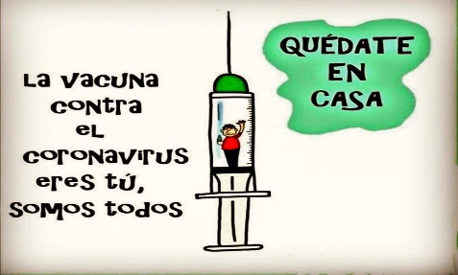 Liceo José Victorino Lastarria

Rancagua

“*Formando Técnicos para el mañana”*

Unidad Técnico-Pedagógica

**English worksheet**

**3rd Grade Gastronomy**

Name: ______________________________ Date: _____________ Class: 3rd _________________

Clase 9 del 1 al 5 de Junio

OA 3: Redactar textos cortos con temáticas conocidas.

Objetivo: Reconocer y reforzar vocabulario visto y crear oraciones relacionadas.

Instrucciones: Desarrollar cada ejercicio, luego reenviarlas al correo de su correspondiente profesor de asignatura.

Camilo Guarda: Camilo [guarda1989@gmail.com](mailto:guarda1989@gmail.com)

Sergio Masciocchi: [smasciocchib@gmail.com](mailto:smasciocchib@gmail.com)

**Match every vegetable with its image.**

*Une cada vegetal con su imagen.*

**onions peas radishes peppers cucumbers lettuce**

**carrots corn tomato broccoli eggplant cabbage**

**potatoes pumpkin mushrooms**



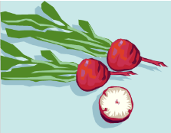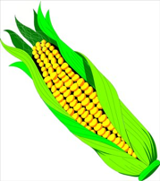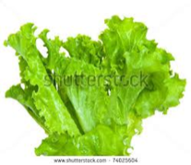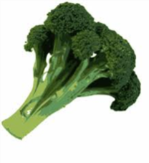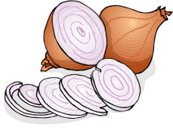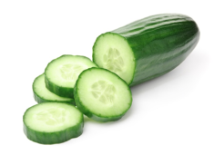

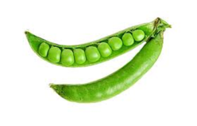

**Match the name image with the name of each cooking utensil.**

*Une la imagen con el nombre de cada utensilio de cocina.*

napkin – knife – whisk – colander – frying pan – oven tray – plate – glass – blender – fork

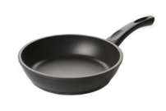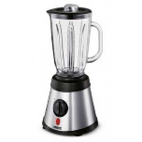

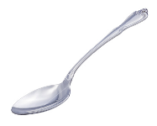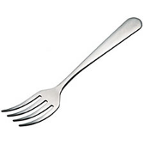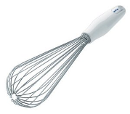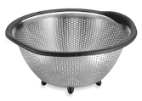

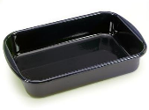

**Answer the following questions.**

*Responde las siguientes preguntas.*

Do you often do any cooking?

Do you like cooking? (Why/ Why not?)

What cooking experience have you had?

Who taught you to cook?

When you were a child, did you ever help your parents to prepare a meal?

Do you think children should help their parents prepare meals?