 Liceo José Victorino Lastarria

Rancagua

“*Formando Técnicos para el mañana”*

Unidad Técnico-Pedagógica

**English worksheet: Reading / Body parts**

**3rd Grade Nursing**

Name: ______________________________ Date: _____________ Class: 3rd _________________

Clase 7 del 11 al 15 de mayo.

OA 2: Demostrar comprensión lectora de un texto adaptado relacionado partes del cuerpo

Instrucciones: Desarrollar cada ejercicio, luego reenviarlas al correo de su correspondiente profesor de asignatura.

Objetivo de la clase :Reconocer partes del cuerpo y dolores a través de un poema.

Camilo Guarda: Camilo [guarda1989@gmail.com](mailto:guarda1989@gmail.com)

Sergio Masciocchi: [smasciocchib@gmail.com](mailto:smasciocchib@gmail.com)

**Reading**

1. 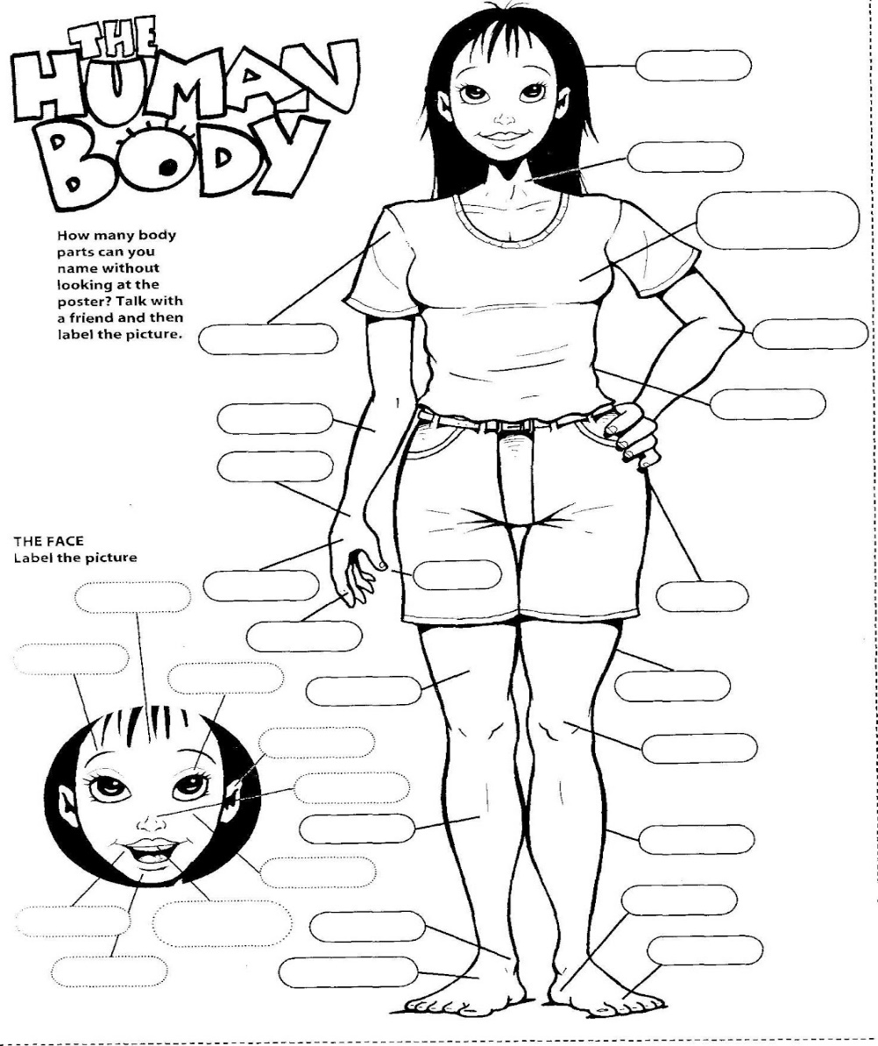Read the poem, identify the parts of the body and write them in the image. ***(Lea el poema, identifique las partes del cuerpo y escríbalas en la imagen, no use todos los espacios)***

**Body Parts**

Two Little **hand** and two little **legs**

One big **back** and one big **chest**

Ten little **fingers** ten little **toes**

Two little **eyes** and one little **nose**

Two little **ears** and two little **feet**

One little **mouth** with lots of **teeth**

Rosy **lips** and big **forehead**

And lot of **hair** on the **head**

One little **chin** and two **elbows**

Two little **ankles** and two **eyebrows**

One long **neck** and two chubby **cheeks**

Two long **arms** and two round **knees**.

These are the parts of my body

And they live with me.

**NEW VOCABULARY: *(TRADUZCA EL SIGUIENTE VOCABULARIO)***

1.- Head = ___________ 16.- elbow = __________

2.- neck = ___________ 17.- forearm = __________

3.- face = ___________ 18.- stomach = __________

4.- eye = ___________ 19.- hip = __________

5.- ear = ___________ 20.- waist = __________

6.- nose = ___________ 21.- hand = __________

7.- mouth = ___________ 22.- fingers = __________

8.- teeth = ___________ 23.- thumb = __________

9.- chin = ___barbilla_ 24.- thigh = __________

10.- heart = ___________ 25.- leg = __________

11.- throat = ___________ 26.- knee = __________

12.- shoulder = ___________ 27.- ankle = __________

13.- arm pit = __axila_____ 28.- foot = __________

14.- chest = ___________ 29.- heel = __________

15.- arm = ___________ 30.- toes = __________

**ACHES AND PAINS:**

1.- A pain = _______________ 11.- a sprain = ____________

2.- an ache = _______________ 12.- stiff = ____________

3.- a bruise = _______________ 13.- sore throat = ___dolor de garganta

4.- a rash = _______________ 14.- a headache = ____________

5.- a cut = _______________ 15.- a cold = ____________

6.- a scar = _____Una cicatriz_ 16.- a stomachache = un dolor de estómago

7.- a swelling = _______________ 17.- temperature = ____________

8.- a graze = _______________ 18.- a cough = ____________

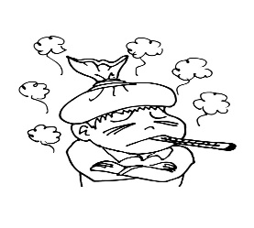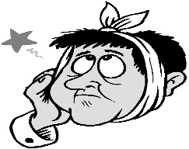9.- a sting = _______________

10.-a bite = ___una mordida_

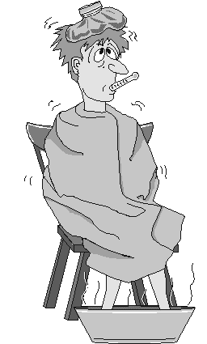a) To ache = _______________

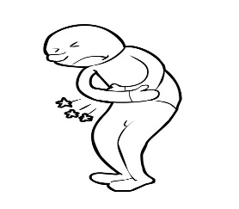b) to hurt = ____Lastimar___

c) to throb = _______________

d) to itch = ____Picar___

e) to irritate = _______________

1.- I have (I’ve got) a pain in my chest = ____Tengo un dolor en mi pecho______

´´ ´´ A stomachache = _______________________________

´´ ´´ An earache = _______________________________

´´ ´´ A toothache = _____Tengo un dolor de muelas_____

´´ ´´ A bad cold = ________________________________

´´ ´´ A sore throat = _____Tengo dolor de garganta___

2.- I feel sick = _________________

´´ ill = ____Me siento enfermo_

´´ awful = _________________

3.- My leg hurts = _________________________________

4.- Why don’t you lie down = ___________________________

´´ ´´ go home = _______Por qué no te vas a casa___

´´ ´´ see a Doctor = ___________________________