Liceo José Victorino Lastarria
Rancagua
“Formando Técnicos para el mañana”
Unidad Técnico-Pedagógica

English worksheet: Writing Reported Speech
3rd Grade Gastronomy

Name: ______________________________ Date: _____________ Class: 3rd _________________

Clase 7 del 11 al 15 de Mayo
OA: 9,10,11,12: Demostrar comprensión lectora de textos no literarios.
OA 13,14,15,16: Escribir una variedad de textos para expresar, describir o narrar, utilizando reported speech.
Objetivo de la clase: Reconocer vocabulario de frutas y verduras.

Instrucciones: Desarrollar cada ejercicio, luego reenviarlas al correo de su correspondiente profesor de asignatura.
Camilo Guarda: Camilo guarda1989@gmail.com
Sergio Masciocchi: smasciocchib@gmail.com

Into the Kitchen 2
- Label each picture with a word from the box.
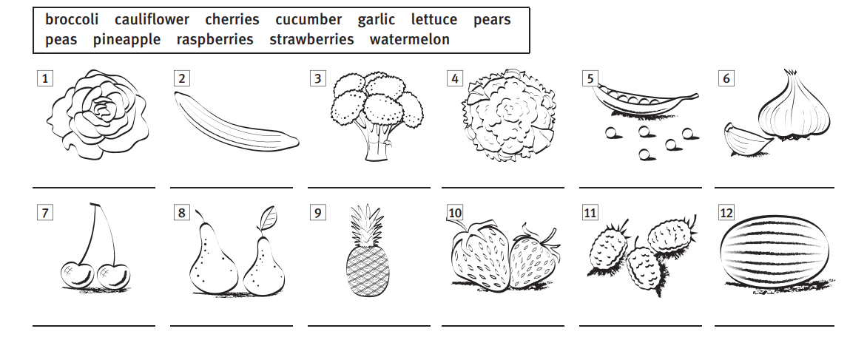
(Etiqueta cada imagen una palabra del recuadro)

- Describe each picture using a word from box A and B
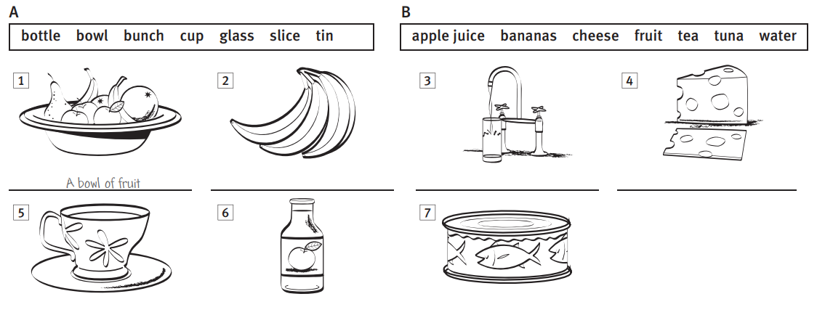
(describe cada imagen usando una palabra de la columna A y B)

- Read the following text and answer the questions.

“Last year, I decided to change my eating habits. I was having an overweight issue and feeling a little bit bad about myself, so I checked on some options to improve my life. A friend told me to go vegetarian and stop eating meat but I have always loved barbecues and roasted meat so I asked for more options. The girlfriend of my friend, that was more intense about her feelings, told me too become vegan, that is even more difficult, because you can’t eat anything coming from an animal, goodbye cheese, goodbye milk, goodbye eggs! Finally, I took the right decision and went to the nutritionist, he advised me to measure the calories and carbs I was ingesting and to do exercise. Best piece of advice ever!”

- What is the text about?
- Going vegan
- Improving life quality
- Preparing a barbecue.

- What does Overweight mean?
____________________________________

- What three things does the speaker mention to stop eating if he went vegan?
_____________________________________
- Which other word could you use to replace “Ingesting”?
_________________________________

- Which piece of advice would you give about eating healthy?
_________________________________

