Liceo José Victorino Lastarria
Rancagua
“Formando Técnicos para el mañana”
Unidad Técnico-Pedagógica

English worksheet: Reading / My body
3rd Grade Nursing PIE

Name: ______________________________ Date: _____________ Class: 3rd _________________

Clase 6 del 27 al 30 de abril.
OA 2: Demostrar comprensión lectora de un texto adaptado relacionado a “My body”
Instrucciones: Desarrollar cada ejercicio, luego reenviarlas al correo de su correspondiente profesor de asignatura.
Camilo Guarda: Camilo guarda1989@gmail.com
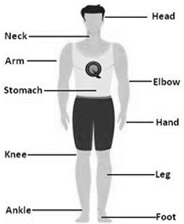
Sergio Masciocchi: smasciocchib@gmail.com
Reading

The Human Body

The principal parts of the human body are: the head, the trunk and the limbs.
We have hair on the head. Inside the head, we have the brain. We think with our brain. Between the forehead and the eyes we find the eyebrows. We see with our eyes. The principal parts of the eyes are: the eyelids and the eyelashes. Between the eyes and the mouth, we see the nose. We smell with our nose. The mouth has lips, teeth and tongue. We eat talk, drink and smile with our mouth. We kiss with our lips and chew with our teeth. Between the chin and the eyes, we find the cheeks. On both sides of the head, we find the ears we hear with our ears. The neck joins the head to the trunk.

In our trunk, we have the chest. Inside the chest, we find the heart and the lungs. The abdomen separates the chest from the waist. In the back, there is the backbone.
We have four limbs: two arms and two legs. The principal parts of the arm are: the shoulder, the elbow, the wrist and the hand. The hand has five fingers: the thumb, the fore finger, the middle finger, the ring finger, and the little finger, the fingers have nails. The principal parts of the leg are: the thigh, the knee, the shin, the calf, the ankle, the foot and the toes.

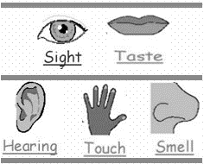

We have five senses: sight, hearing, taste, smell, and touch.

Activities
I.- WRITE IN YOUR COPYBOOK THE BOLD WORDS AND FIND OUT THEIR MEANING: Escribe en tu cuaderno las palabras en negrita y busca su significados:
II. Write TRUE or FALSE according to the text. (Escriba VERDADERO o FALSO de acuerdo al texto)
1. The main parts of our body are the head and the eyes. _____

2. We smell with our nose. _____

3. Inside out chest we have the brain. _____

4. We have three arms and 4 legs. _____

5. We have five six senses. _____

III. Using the description below, draw the human body described. (Utilizando las descripciones abajo, dibuje el cuerpo humano descrito)
1. This human body has 2 heads, 3 legs, 1 arm, 6 ears, 2 mouths and no chest. (2 manos, 3 piernas, 1 brazo, 6 oídos, 2 bocas y no tiene pecho)
2. This human body has 1 head, 2 hands, 2 legs.
3. This human body has 1 nose, 2 eyes, 2 hands and 2 feet.

