Liceo José Victorino Lastarria
Rancagua
“Formando Técnicos para el mañana”
Unidad Técnico-Pedagógica

English worksheet: Kitchen
3rd Grade Gastronomy

Name: ______________________________ Date: _____________ Class: 3rd _________________

Clase 6 del 4 al 8 de Mayo
OA:2, OA4: Conocer implementos y términos encontrados en una cocina.
Instrucciones: Desarrollar cada ejercicio, luego reenviarlas al correo de su correspondiente profesor de asignatura.
Camilo Guarda: Camilo guarda1989@gmail.com
Sergio Masciocchi: smasciocchib@gmail.com
Into the Kitchen
- Select the correct name for each image.
Selecciona la palabra correcta para cada imagen.
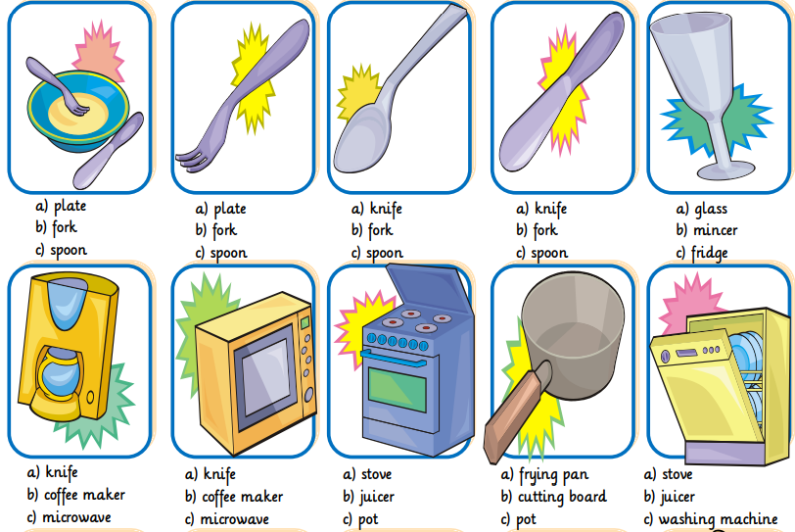

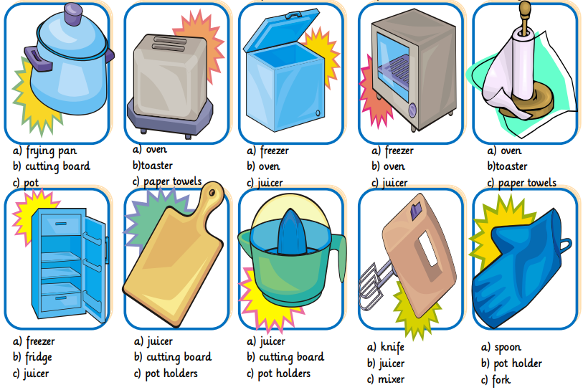

- Read the following text and answer the questions.

“Twenty chefs from distant countries have come here to prove they are the best among the best. On each episode, they will have to prepare a special dish that will be judge by a special jury. Once the first round is done, one chef will be granted immunity and the two chefs that cooked the worst dishes, will face each other on an elimination challenge. Prepare yourself to witness top chefs of the world cook with the strangest ingredients from all over the globe in a competition to become the best chef in the world”

- ¿What is the text about?
- A recipes youtube streaming
- A t.v. programme
- A live cooking class

- ¿ How many chefs participate?
____________________________________

- ¿ How many rounds does each episode have?
- 1
- 2
- 3

- When they mention the “strangest ingredients all over the globe”, Which ones do you imagine?
_________________________________

- Do you admire a famous chef?
_________________________________

