Liceo José Victorino Lastarria
Rancagua
“Formando Técnicos para el mañana”
Unidad Técnica Pedagógica
English worksheet: Famous people and Reported Speech
3rd Grade Nursing/Gastronomy

Name: ______________________________ Date: _____________ Class: 3rd _________________

Clase del 30 de Marzo al 03 de Abril.
OA: 9,10,11,12: Demostrar comprensión lectoras de textos no literarios identificando ideas generales y especificas.
OA 13,14,15,16: Escribir una variedad de textos para expresar, describir o narrar, utilizando reported speech.
Instrucciones: Desarrollar cada ejercicio, luego reenviarlas al correo de su correspondiente profesor de asignatura.
Camilo Guarda: Camilo guarda1989@gmail.com
Sergio Masciocchi: smasciocchib@gmail.com
Reading comprehension

Read the text and solve the exercises.
My name`s Daniel and my surname’s Radcliffe. I’m from London, in England. I’m an actor, the protagonist of Harry Potter. I’m twenty years old.
I have got parents. They are from England, too. My father’s name is Alan. He’s a literary agent and he’s 50 years old. My mother`s name is Marcia and she’s an actress and a film director. She’s 42 years old. I haven’t got brothers or sisters. I have got a grandfather and a grandmother. I have got four aunts and three uncles. I haven’t got cats, but I have got two dogs. Their names are Binka and Nugget.
My favourite TV show is The Simpsons. My favourite sports are football and cricket. My favourite colours are blue and yellow.

A) ARE THE SENTENCES TRUE OR FALSE?

1. Daniel is Harry Potter. ..... 4. His sister’s name is Marcia. .....
2. He`s an actor from England. ..... 5. His dogs’ names are Binka and Alan. .....
3. His father is 50. .....

B) ANSWER ABOUT DANIEL.

1. How old is Daniel? ............................................................
2. Where is Daniel’s father from? .........................................
3. Is his mother an actress? ....................................................
4. Is volleyball his favourite sport? .......................................

Reported Speech

C) Harry Potter and his friend are thinking a lot of things. Transform their thoughts in reported speech and translate.
3 I can make a magic potion.
1 I love this teacher.
2 We want to play
Quidditch.
4 I want Harry Potter to ask me out.
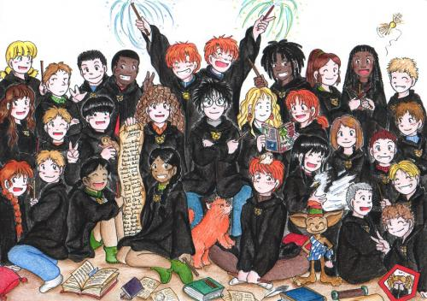
7 Harry Potter is my hero.
10 Why do I have to stay in this school?
6 My owl brought me a letter today.
11 I don’t understand this book.
12 We learn how to make a spell.
8 I miss my parents.
9 I have got a new broom.
5 Harry is my best friend.
14 I must find the Sorcerer’s stone.
13 I transformed him in a cat.
- ..........She told that she loved that teacher (ELLA DIJO QUE AMABA A ESE PROFESOR) .........
- .................................................................................................................................................
- .................................................................................................................................................
- .................................................................................................................................................
- .................................................................................................................................................
- .................................................................................................................................................
- ..........He told that Harry Potter was his hero (ÉL DIJO QUE HARRY POTTER ERA SU HÉROE).
- .................................................................................................................................................
- .................................................................................................................................................
- .................................................................................................................................................
- .................................................................................................................................................
- .................................................................................................................................................
- .................................................................................................................................................
- .................................................................................................................................................

