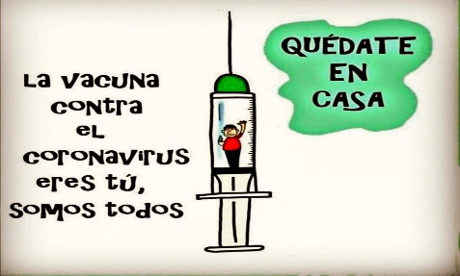
Liceo José Victorino Lastarria
Rancagua
“Formando Técnicos para el mañana”
Unidad Técnico-Pedagógica
Departamento de Inglés
English worksheet: FEEDBACK

Name: ___________________________Date: ________________ Class: 2nd______

Clase del 8 al 12 de Junio
Segundo Medio
OA: 1,2,3,4,5,6,7,8: Demostrar comprensión de ideas generales e información explícita en textos orales adaptados y auténticos simples, literarios y no literarios, en diversos formatos audiovisuales
OA 13,14,15,16: Escribir una variedad de textos para expresar, describir o narrar, utilizando diferentes tiempos verbales.
Objetivo: Retroalimentar contenido visto en las guías 1,2,3 y 4.
Instrucciones: Copiar cada ejercicio en su cuaderno, tomar foto y luego reenviarlas al correo de su correspondiente profesor de asignatura.
Profesor Camilo Guarda: camiloguarda1989@gmail.com
Profesor Raúl López: lpez.raul@gmail.com

Guía 1:

Item 1:
- play – doesn’t write – do you speak – goes – does she water – dance – don’t drink – does she have – works – doesn’t read – takes – do – read – don’t like – does she wear – speaks – do you go – does he work – do they know – don’t understand.

Item 2:
- thinks – don’t know – does she feel – doesn’t look – don’t know – washes – sleeps – play – wins – cries – prays – doesn’t like – does Jhon play – does she drink – do they love – does Mary believe – do they watch.

Item 3:
- Kisses – Fixes – Catches – Does – Cries – Prays – Reads – Goes – Misses – Teaches – Fixes – Finishes – Puts – Publishes – Makes – Copies – Cleans – Learns.

Item 4:
- They play soccer at school – She does not write emails – Do you speak English? – Isidora likes tea very much – Mike dos not like cumbias – Do you like Bad Bunny? – She does not wake up early on Sundays.

Guía 2:

Item 1:
- Went – Decided – Hurried – Didn’t walk – Didn’t play – Buried – Did you watched.

Guía 3:

Item 1:
- A – C – C – C – B

Item 2:
- Met – Drove – Spoke – Put – Wrote – Sang – Did – Sat – Stood – Ran

Item 3:
- enjoyed – played – stayed – travelled – talked – walked – liked – stopped – listened – watched.

Item 4:
- went – didn’t cook – walked – did the killer bury – did – didn’t play – did you go – did he carry – had – broke

Guía 4:

Item 1:
- was – stayed – had – did – went – watched – drove – visited – saw – didn’t like – wasn’t – met – learned – was – promised

Item 2:
No existen respuestas específicas. La producción debía apuntar a idealmente algo como:
I went to the beach – I did not play volleyball. I visited my grandmother – I didn’t eat hot dogs.

Se espera que el estudiante sea capaz de expresar diferentes acciones pasadas las cuales sí fueron realizadas y, a su vez, acciones que no se realizaron, por medio de las estructuras de pasado simple revisadas anteriormente

