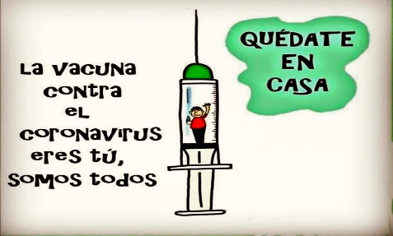
Liceo José Victorino Lastarria
Rancagua
“Formando Técnicos para el mañana”
Unidad Técnico-Pedagógica
Departamento de Inglés
English worksheet: FEEDBACK

Name: ___________________________Date: ________________ Class: 1st______

Clase del 8 al 12 de Junio
Primero Medio
OA: 1,2,3,4,5,6,7,8: Demostrar comprensión de ideas generales e información explícita en textos orales adaptados y auténticos simples, literarios y no literarios, en diversos formatos audiovisuales
OA 13,14,15,16: Escribir una variedad de textos para expresar, describir o narrar, utilizando diferentes tiempos verbales.
Objetivo: Retroalimentar contenido visto en las guías 1,2,3 y 4
Instrucciones: Copiar cada ejercicio en su cuaderno, tomar foto y luego reenviarlas al correo de su correspondiente profesor de asignatura.
Profesor Camilo Guarda: camiloguarda1989@gmail.com
Profesor Raúl López: lpez.raul@gmail.com

Guía 1:

Item 1:
- A – C – C – C – B – B – A – A – C – A – B – B – A – C – B
Item 2:
- MET – DROVE – SPOKE – PUT – WROTE – SANG – DID – SAT – STOOD – RAN
Item 3:
- enjoyed – stayed – played – travelled – phoned – walked – liked – stopped – listened – talked.
Item 4:
- went – didn’t cook – walked – did the killer bury – did – didn’t play – did you go – did he carry – had – broke.
Item 5:
- did – chose – got – talked – found – helped – asked – made – told.

Guía 2:

Item 1:
- wasn’t reading – was surfing – were/talking – was drinking/was kissing – were buying/was paying.

Guía 3:

Item 1:
- Was living: estaba viviendo – I used to go to a lot of concerts: Yo solía ir a muchos conciertos – She sang for over two hours: Ella canto por más de 2 horas.
Item 2:
- was playing – was reading – was doing – weren’t eating – were you calling – were watching – wasn’t doing – was sleeping – was cooking – was she jumping

Item 3:
- C – D – C – D – C – D

Guía 4:

Item 1:
- It was raining and thundering all day – She wasn’t playing outside – She was feeling tired of being trapped inside the house – She was reading her book until the electricity went out – She was practicing sewing until lunchtime – Her mother was calling to say she was coming home – She was having such a good time with her mom.

Item 2:
No existen respuestas específicas, pero idealmente responder algo como:
- I was playing soccer – I was eating outside – I was talking to you – He was talking by phone.

Se espera que el estudiante sea capaz de relacionar alguna acción en progreso en el pasado, la cual fue interrumpida por otra, las cuales son mencionadas en la segunda columna del recuadro.

