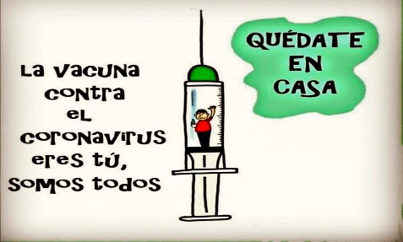
Liceo José Victorino Lastarria
Rancagua
“Formando Técnicos para el mañana”
Unidad Técnico-Pedagógica
Departamento de Inglés
English worksheet: General Review
1st ^{Grade}

Name: ___________________________Date: ________________ Class: 1st______

Clase del 1 al 5 de Junio
OA: 1,2,3,4,5,6,7,8: Demostrar comprensión de ideas generales e información explícita en textos orales adaptados y auténticos simples, literarios y no literarios, en diversos formatos audiovisuales
OA 13,14,15,16: Escribir una variedad de textos para expresar, describir o narrar, utilizando diferentes tiempos verbales.
Objetivo: Reforzar contenido visto previamente.
Instrucciones: Desarrollar cada ejercicio y enviar guía a su correspondiente profesor de asignatura.
Profesor Camilo Guarda: camiloguarda1989@gmail.com
Profesor Raúl López: lpez.raul@gmail.com

- Choose the correct alternative using Past Continuous. (Selecciona la alternativa correcta utilizando Pasado Continuo).

1. At 5.30 am, we______________ to create the English Final test.
a) was finishing
b) are finishing
c) were finishing

2. I ____________ by the lake, while your cousins _______________ on it.
a) was drinking - was swimming
b) were drinking - was swimming
c) was drinking - were swimming

3. Gareth ______________ the piano, he _____________ with the guitar.
a) was not playing - was practicing
b) were not playing - was practicing
c) wasn't playing - wasn't practice

4. Because of the heat, the snowman ____________ under the sun.
a) was melt
b) were melting
c) was melting

5. I'm so embarrassed! Charles and Carl ______________ about the dinner.
a) were complaining
b) was complaining
c) are complaining

6. Sue and Jane ______________ fruits to pay the rent.
a) were selling
b) were sold
c) were sells

- Using your own ideas, and considering the structures, complete the following sentences using Past Continuous. (Usando tus propias ideas, y considerando las estructuras, complete las siguientes oraciones usando Pasado Continuo).
YOUR SENTENCE IN PAST CONT. | REST OF THE SENTENCE
Example: I was playing Free Fire…. | when my mother called me.
1. | when the light went out.
2. | when the teacher sent the homework.
3. | when my friend broke the window.
4. | when I was on the phone.
5. | when the earthquake started.
En esta columna debes escribir lo que “estabas haciendo” antes de que sucediera | Esta es la situación que “interrumpió” lo que estabas realizando en la columna anterior

- Check the following video and choose the correct word. (Revisa el siguiente video y selecciona la palabra correcta).

Video: https://youtu.be/HI1ln-jnbY0

- “I was shopping/choosing at the supermarket”
- “I was waiting/sleeping at the bus stop at 10 o’clock”
- “I was reading/feeding my dog at 11 o’clock”
- “I was taking/having a shower now when you called at 12 o’clock”
- “No, I didn’t. Look in your pockets/rockets”

