 Liceo José Victorino Lastarria

Rancagua

“*Formando Técnicos para el mañana”*

Unidad Técnico-Pedagógica

Departamento de Inglés

**English worksheet: Reading Comprehension**

**1st Grade**

Name: ___________________________Date: ________________ Class: 1st______

Clase del 4 al 8 de Mayo

OA: 1,2,3,4,5,6,7,8: Demostrar comprensión de ideas generales e información explícita en textos orales adaptados y auténticos simples, literarios y no literarios, en diversos formatos audiovisuales

OA 13,14,15,16: Escribir una variedad de textos para expresar, describir o narrar, utilizando pasado continuo.

Instrucciones: Desarrollar cada ejercicio y enviar guía a su correspondiente profesor de asignatura.

Profesor Camilo Guarda: [camiloguarda1989@gmail.com](mailto:camiloguarda1989@gmail.com)

Profesor Raúl López: [lpez.raul@gmail.com](mailto:lpez.raul@gmail.com)

**Reading Comprehension**

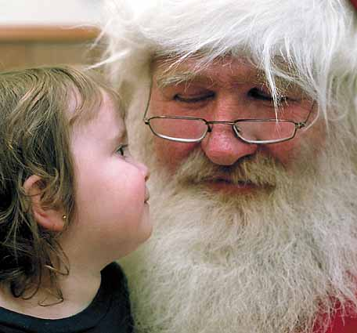Santa Claus, also known as Saint Nicholas, Father Christmas, Kris Kringle, or simply "Santa", is a figure which was derived from the Dutch figure of Sinterklaas, a historical, legendary and mythological figure who in many Western cultures, is said to bring gifts to the homes of the good children during the late evening and overnight hours of Christmas Eve, December 24 or on his Feast Day, December 6 (Saint Nicholas Day).The legend is based on the tales concerning the historical figure of gift giver Saint Nicholas. While Saint Nicholas was originally portrayed wearing bishop's robes, today Santa Claus is generally depicted as a plump, jolly, white-bearded man wearing a red coat with white collar and cuffs, white-cuffed red trousers, and black leather belt and boots (images of him rarely have a beard with no mustache). This image became popular in the United States and Canada in the 19th century due to the significant influence of caricaturist and political cartoonist Thomas Nast. This image has been maintained and reinforced through song, radio, television, and films. In the United Kingdom and Europe, he is often depicted in a manner identical to the American Santa Claus, but he is commonly called Father Christmas.

**I. Read the text and select the correct alternative.**

**1) Santa Claus is also known as:**

a) Father Christmas

b) Saint Nicholas

c) Kris Kringle

d) All of them

**2) Santa provides gift in:**

a) Summer

b) 29th February

c) Christmas Eve

d) United States and Canada

**3) Santa can be described as:**

a) A big fat man with a white coat

b) A plump, jolly, white-bearded man

c) A man with long hair and no bear

d) An old man with red coat and horns

**4) Santa became popular thanks to:**

a) Thomas Nast

b) The president of USA and Canada

c) Children’s beliefs

d) Kris Kringle

**5) The image of Santa has been reinforced by:**

a) Newspapers

b) Music, radio, TV, and movies

c) Politicians

d) Saint Nicholas Day

**6) Santa is called Father Christmas in:**

a) UK and Europe

b) USA and Canada

c) All over the world

d) South America

**II. Write True (T) or False (F).**

1. ____ Santa Claus goes to the good children’s houses

2. ____ The image of Santa was reinforced thanks to Internet

3. ____ Santa uses only moustache

4. ____ Santa is a historical, legendary, and mythological image

5. ____ The image of Santa became popular in the 18th century

6. ____ Santa became popular in USA and UK

7. ____ He is called Father Christmas in Canada

8. ____ Santa is a figure derived from the Dutch figure of Sinterklaas