 Liceo José Victorino Lastarria

Rancagua

“*Formando Técnicos para el mañana”*

Unidad Técnico-Pedagógica

Departamento de Inglés

**English worksheet: Reading Comprehension**

**1st Grade PIE**

Name: ___________________________Date: ________________ Class: 1st______

Clase del 4 al 8 de Mayo

OA: 1,2,3,4,5,6,7,8: Demostrar comprensión de ideas generales e información explícita en textos orales adaptados y auténticos simples, literarios y no literarios, en diversos formatos audiovisuales

OA 13,14,15,16: Escribir una variedad de textos para expresar, describir o narrar, utilizando pasado continuo.

Instrucciones: Desarrollar cada ejercicio y enviar guía a su correspondiente profesor de asignatura.

Profesor Camilo Guarda: [camiloguarda1989@gmail.com](mailto:camiloguarda1989@gmail.com)

Profesor Raúl López: [lpez.raul@gmail.com](mailto:lpez.raul@gmail.com)

**Reading Comprehension** *(Lectura Comprensiva)*

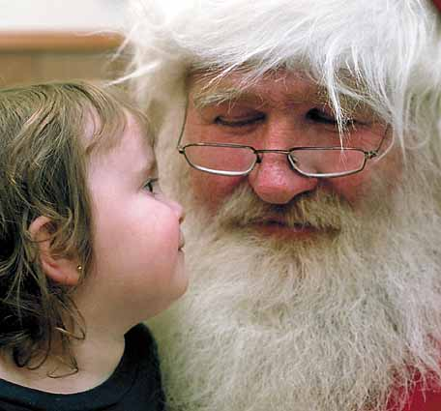**1-**Santa Claus, also known as Saint Nicholas, Father Christmas, Kris Kringle, or simply "Santa", is a figure which was derived from **2-**the Dutch figure of Sinterklaas, a historical, legendary and mythological figure who in many **3-**Western cultures, is said to bring gifts to the homes of the good children during the late **4-**evening and overnight hours of Christmas Eve, December 24 or on his Feast Day, December 6 **5-**(Saint Nicholas Day).The legend is based on the tales concerning the historical figure of gift **6-**giver Saint Nicholas. While Saint Nicholas was originally portrayed wearing bishop's robes, **7-**today Santa Claus is generally depicted as a plump, jolly, white-bearded man wearing a red coat with white collar and cuffs, **8-**white-cuffed red trousers, and black leather belt and boots (images of him rarely have a beard with no mustache). This image **9-**became popular in the United States and Canada in the 19th century due to the significant influence of caricaturist and political **10-**cartoonist Thomas Nast. This image has been maintained and reinforced through song, radio, television, and films. In the United **11-**Kingdom and Europe, he is often depicted in a manner identical to the American Santa Claus, but he is commonly called Father **12-**Christmas.

**I. Read the text and select the correct alternative.** *(Lee el texto y selecciona alternativa correcta)*

**1) Santa Claus is also known as:** *(línea 1)*

a) Father Christmas

b) Saint Nicholas

c) Kris Kringle

d) All of them

**2) Santa provides gift in:** *(línea 4)*

a) Summer

b) 29th February

c) Christmas Eve

d) United States and Canada

**3) Santa can be described as:** *(línea 7-8)*

a) A big fat man with a white coat

b) A plump, jolly, white-bearded man

c) A man with long hair and no bear

d) An old man with red coat and horns

**4) Santa became popular thanks to:** *(línea 9-10)*

a) Thomas Nast

b) The president of USA and Canada

c) Children’s beliefs

d) Kris Kringle

**5) The image of Santa was reinforced by:** *(linea 10)*

a) Newspapers

b) Music, radio, TV, and movies

c) Politicians

d) Saint Nicholas Day

**6) Santa is called Father Christmas in:** *(linea 11-12-13)*

a) UK and Europe

b) USA and Canada

c) All over the world

d) South America

**II. Write the missing words to complete the sentence.** *(Escribe las palabras faltantes para completar las oraciones).*

1. Santa Claus, also known as ____________________________________________________, or simply "Santa"

2. A historical, __________________________________________________________________________ figure

3. The legend is based on __________________________________________________________ Saint Nicholas

4. Santa Claus is generally depicted as ____________________________________________ wearing a red coat

5. This image became popular____________________________________________________________ century

6. This image has been maintained and reinforced through ______________________________________ films

7. In the United Kingdom and ______________, he is often depicted in a manner identical to the American Santa Claus, but he is commonly called ___________________________________.